**Sustainable Outreach And Universal**

**Leadership (SOUL) Limited**

**Software Requirement Specification (SRS)**

Of

**Training of Trainers (ToT) module**

For Implementation of

**Campus Management Software**

at

**World Skill Center (WSC)**

**Table of Content**

A. Abstract 3

B. Introduction 3

C. Definition, Acronyms and Abbreviations 3

D. Overview of the Document 3

E. Scope of Education Module 4

F. WSC Student ToT Process Flow 5

G. WSC Student ToT Process Flow Description 6

H. List of Screens and their Descriptions 7

I. Training of Trainers 9

1. Masters 9

1.1 Department 9

1.2 Programs 11

1.3 Course 14

1.4 Semester 16

1.5 Topic 18

2. Admission 19

2.1 Student 19

2.2 Program Enrollment 26

2.3 Course Enrollment 33

2.4 ToT candidate list 36

2.5 ToT candidate selection 40

2.6 ToT candidate reporting 41

3. Academics 43

3.1 Student Group 43

3.2 Instructor 45

3.3 Course Schedule 48

3.4 Course Scheduling Tool 50

3.5 Student Attendance 52

3.6 Student Attendance Tool 54

3.7 Assignment 55

3.8 Assignment Upload 57

4. Examination 59

4.1 Exam Declaration 59

4.2 Criteria Wise Evaluation 67

4.3 Criteria Wise Evaluation Tool 70

4.4 Continuous Evaluation 72

4.5 Continuous Evaluation Tool 75

4.6 Final Exam Result 77

4.7 Final Result Declaration Tool 80

# Abstract

Software Requirements Gathering is one of the first phases of system development. This phase results in the Software Requirements Specification (SRS) document, which must contain a complete, concise, high-quality description of the system being considered.

# Introduction

The World Skill Center (WSC) is a premier advanced skill training institute established by the Government of Odisha, Skill Development and Technical Education Department, through the Odisha Skill Development Authority (OSDA). The WSC will impart advanced skill training in eight trades from engineering and service sectors. WSC caters primarily to induct the best talent from ITIs and Polytechnics and train them to become globally employable in emerging areas such as "Industry 4.0". WSC is housed in a state-of-the-art, 18-storey, air-conditioned building with nearly half a million square feet of space in the heart of capital city of Bhubaneswar.

With the Implementation of campus management software for WSC the goal is to streamline the operations and functions of the campus by integrating various processes, such as admissions, course registration, academic progress tracking, and financial management, HRMS, Procurement and Inventory management, etc into a unified system. The implementation also aims at providing a user-friendly interface for all stakeholders, making it easier for them to access the necessary information and complete their tasks with ease. The modules to be covered during the implementation of the software includes:

|  |  |
| --- | --- |
| Students Management Modules | Infrastructure Management |
| Academic System | Finance and Accounting System |
| Procurement & Inventory Management | Training and Placement |
| Human Resources Management System | Application Integration |

# Definition, Acronyms and Abbreviations

The following table explains the terms and abbreviations used in the document:

|  |  |
| --- | --- |
| **Abbreviation** | **Description** |
| SRS | Software Requirements Specification |
| SLCM | Student Life Cycle Management |
| R | Rename - When a field is Renamed |
| N | New - When a New field is Added |
| D | Delete - When an Existing field is Deleted |
| NA | Not Applicable |

# Overview of the Document

This requirement document provides a detailed overview of the functional requirements of a project. It serves as a communication tool between stakeholders, including developers, project managers, and end-users. The purpose of this requirement document is to define and document the project's objectives, scope, and expectations, and to ensure that all stakeholders have a clear understanding of what the project entails.

This document covers all the functional requirements of the **Training of Trainers (ToT) module** of ERP Product. This module helps in organizing the entire Tot set-up, such as ToT Candidate Database, ToT Application Form, Fee Structure, Course Enrollment, ToT Candidate Attendance, Exam Evaluation, Certificate Generation, etc.

# Scope of Education Module

* Courses and Subjects, Timetable preparation and management  ▪
* Class occurrence monitoring
* Class Attendance of students (Face recognition or any other automated mode).    ▪
* Results Analysis after declaration of results by WSC ▪
* Students Feedback mechanism on quality of teaching learning ▪ Internship, Training, Apprentice ▪
* Re-Admission Process after discontinuing in studies ▪
* Students Back paper tracking etc.
* Students Profile.  :Personal Information, Contact Details, Academic Details ▪
* Issue of Identity Card.  ▪
* Biometric Attendance (Face recognition) ▪
* Hostel Management (Hostel seat allotment, attendance, fees etc) ▪
* Scholarships.  ▪
* Rewards and achievements.  ▪
* Students’ Evaluation/remarks of Faculty.  ▪
* Parent Enquiry/Alert/Messaging Management.  ▪
* Messaging System  ▪
* Students Grievance System etc.

Following functionalities are covered in this SRS document:

* **Tot Candidate Details**
* **ToT Candidate Attendance**
* **ToT Exam Conducting**
* **Result Publication**
* **Certificate Generation**

# WSC Student ToT Process Flow

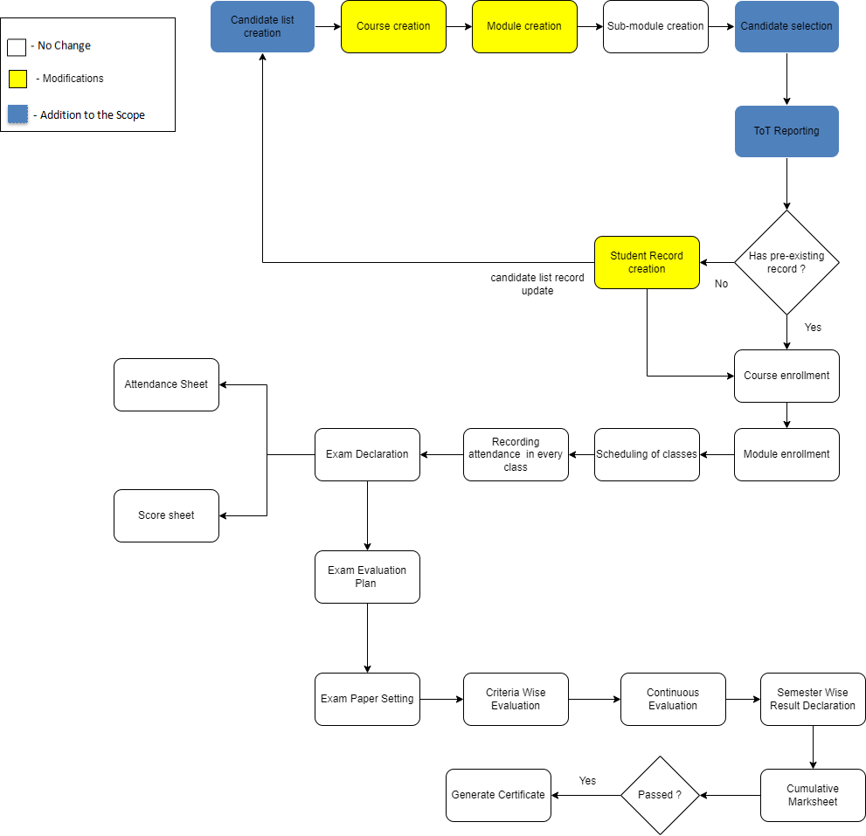

Figure 1 : ToT Process Flow

# WSC Student ToT Process Flow Description

**Candidate list creation**

This allows the user to enter and maintain records of candidates who are eligible for the ToT program in the system.

**Course selection**

This allows the user to create and maintain records of course(s) that will be under the ToT program.

**Module creation**

This allows the user to create and maintain records of module(s) that will be under the ToT program.

**Sub-module creation**

This allows the user to create and maintain records of sub-module(s) that will be under the ToT program.

**Candidate selection**

This allows the user to select candidates for a ToT program from the records maintained in the candidates list.

**ToT reporting**

This allows the user to mark a candidate as present after they have reported on the day of reporting.

**Student record creation**

This allows the user to create a record of a candidate as a student under the ToT program which will later be used to do program enrollment.

**Course enrollment**

This allows the user to enroll a candidate with a record as a student into a course for their training.

**Module enrollment**

This allows the user to enroll a candidate with a record as a student into a module for their training.

**Scheduling of classes**

This allows the user to schedule the classes for a module under the ToT program.

**Recording attendance in every class**

This allows the user to record attendance of candidates during each class under the ToT program.

**Exam declaration**   
This allows the user to declare an exam fro various program in accordance with the ‘Academic Calendar’ template which was used during the start of each session.

**Attendance sheet**

Attendance sheets allows the user to maintain and mark attendance of students present in the examination room.

**Score sheet**

Score sheets are used to record the marks obtained by each student in an examination. The score sheet includes the name of the student, marks obtained in each subject and the total marks achieved by the student.

**Criteria wise evaluation**

Criteria wise evaluation allows to create an evaluation for a particular assessment criteria in a course for a student enrolled in that course

**Continuous evaluation**

It is used to assess the assessment criteria done for a course for an individual student.

**Generate Certificate**

This allows the user to generate a certificate for the candidates after they have met all the criterias required for a certificate.

# List of Screens and their Descriptions

The following tables lists the pages used in ToT module :

|  |  |  |
| --- | --- | --- |
| **Sl no** | **Screen Name** | **Description** |
|  | Department | A Department is a specialized functional area or a division within an organization. |
|  | Programs | The Programs document will hold all the data related to the programs. |
|  | Course | A program will have an educational curriculum defined by user institute to streamline the learning process and goals in each subject or module. |
|  | Semester | A semester is individual part of a program. A semester system divides the academic year into different sessions which have various course enrollments enlisted in them. |
|  | Topic | **A Topic is a sub unit of a Module and will contain all the contents related to the topic.** |
|  | Student | The Student document will hold all the data related to the students. |
|  | Student Group | The Student Group allows you to create a group of students for different classes for the ongoing Academic Year. |
|  | Program Enrollment | Program Enrollment is the record of enrollment of a student in a given program and chosen courses for a particular Academic Term. |
|  | Course Enrollment | Course Enrollment is the record of enrollment of a student in a given program and chosen courses for a particular Academic Term. |
|  | Instructor | An instructor is an employee who will be responsible for teaching a particular topic or course to the students. |
|  | Course Schedule | A course schedule is a specialized functional area or a division within the Groups and schedule. |
|  | Course Scheduling Tool | The Course Scheduling Tool allows a user to create Course Schedules in bulk for the particular Course. |
|  | Student Attendance | The Student Attendance allows you to keep track and mark the attendance of a student for a day. Attendance records can be created against students on a daily basis. |
|  | Student Attendance Tool | The Student Attendance Tool allows user to bulk update the Attendance for Students based on Student Group and Course Schedule. |
|  | Assignment | In Assignment Screen Trainers can easily provide assignment to their respective students, so that it gives a strong bonding between the students and the trainers. |
|  | Assignment upload | In Assignment Upload Screen Students can easily upload their assignment and it will securely go to their respective trainers. |
|  | Exam declaration | The Exam Declaration will allow user to declare an exam for various programs in accordance with the ‘Academic Calendar’ template which was used during the start of each session. |
|  | Criteria wise evaluation | Criteria Wise Evaluation allows us to create an evaluation for a particular assessment criterion in a course for a student enrolled in that course. |
|  | Criteria wise evaluation tool | Criteria Wise Evaluation Tool helps in entering marks earned by the students in a semester for a particular course and particular assessment criteria. |
|  | Continuous evaluation | Continuous Evaluation is used to assess the Assessment Criteria done for a course for an individual student. |
|  | Continuous evaluation tool | Continuous Evaluation Tool is used to assess the Assessment Criteria done for a course for an individual student. |
|  | Final exam result | Final Exam Result is used to evaluate the final assessment of a student for a particular semester. |
|  | Final result declaration tool | Final Result Declaration Tool is used to declare the final exam results for a particular group/batch of students in a semester. |
|  | ToT candidate list | This screen is used for creating and maintaining records of eligible candidates |
|  | ToT candidate selection | This screen is used for selecting candidates for trainings from the maintained ToT candidate list |
|  | ToT candidate reporting | This screen is used for marking a candidate as present on the date of reporting |

# Training of Trainers

Following are the screens used to achieve the functionalities of ToT.

## Masters

### Department

**General Description**

The following table describes overall information about this screen:

|  |  |  |
| --- | --- | --- |
| **Description** | | 1. A Department is a specialized functional area or a division within an organization. 2. User will configure the Departments, set Leave Block List and also Leave and Expense Approvers for the same. 3. Department is a tree-structured master, which means user can create parent departments and sub-departments as shown below |
| **Navigation** | Home > Admission > Masters > Department | |
| **Pre-requisites** | The system should have records in the following screen   1. Company 2. Leave Block List | |
| **Existing Screen Name** | Department | |
| **New Screen Name** | No change | |

**Screenshot**

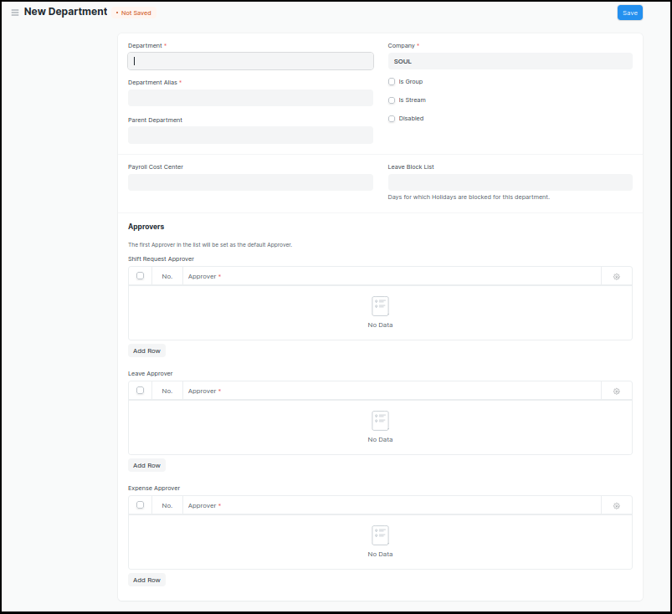

Figure 2 : Department Screen

**Field List**

The following table describes the UI fields present in this screen :

|  |  |  |  |  |  |  |
| --- | --- | --- | --- | --- | --- | --- |
| **ID** | **Field Name** | **Field Type** | **Mandatory** | **Validation/ Action** | **Remarks** | **R/N/D** |
| 1 | Department | Text Field | Yes |  |  |  |
| 2 | Parent Department | Link Field |  |  |  |  |
| 3 | Company | Link Field | Yes | Link Fields to Master Screen Company | Default company name will be fetched |  |
| 4 | Is Group | Checkbox |  | If checked the department will be grouped under a parent department |  |  |
| 5 | Is Stream | Checkbox |  | If checked the department will be considered as a stream E.g (Commerce, Arts, Etc) |  |  |
| 6 | Disabled | Checkbox |  | If checked, the department record will not be able to visible in any transaction |  |  |
| 7 | Payroll Cost Center | Link Field |  |  | Not Applicable for Admission Module |  |
| 8 | Leave Block List | Link Field |  |  | Not Applicable for Admission Module |  |
| 10 | Leave Approver | Table |  |  | Not Applicable for Admission Module |  |
| 11 | Expense Approver | Table |  |  | Not Applicable for Admission Module |  |
| 12 | Shift Request Approver | Table |  |  | Not Applicable for Admission Module |  |

**User: Roles & Permission**

The following table describes the users and their roles and permissions for the screens :

|  |  |  |  |  |  |  |  |  |
| --- | --- | --- | --- | --- | --- | --- | --- | --- |
| **ID** | **Role** | **Read** | **Write** | **Create** | **Delete** | **Submit** | **Cancel** | **Amend** |
| 1 | ToT coordinator/director | Yes | No | No | No | NA | NA | NA |
| 2 | ToT coordinator/administrator | Yes | No | No | No | NA | NA | NA |
| 3 | ToT assistant coordinator/trainer | Yes | No | No | No | NA | NA | NA |

## 

### Programs

**General Description**

The following table describes overall information about this screen:

|  |  |
| --- | --- |
| **Description** | 1. A program will have an educational curriculum defined by user institute to streamline the learning process and goals in each subject or module. 2. For example, Mechatronics would be a program taught at the institute that will have various modules within |
| **Navigation** | Home > Admission >Masters > Programs |
| **Pre-requisites** |  |
| **Existing Screen Name** | Programs |
| **New Screen Name** | Course |

**Screenshot**

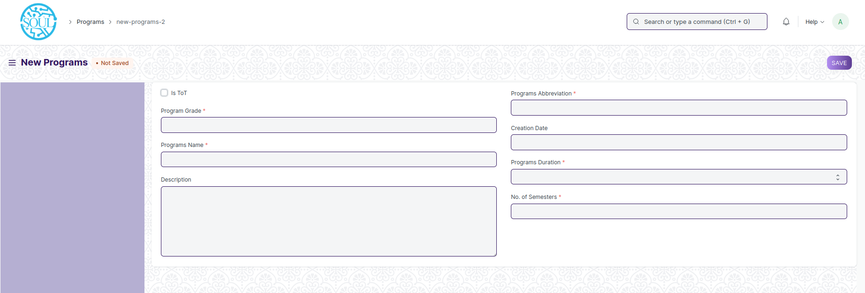Figure 3 : Programs Screen

**Field List**

The following table describes the UI fields present in this screen :

|  |  |  |  |  |  |  |
| --- | --- | --- | --- | --- | --- | --- |
| **ID** | **Field Name** | **Field Type** | **Mandatory** | **Validation/ Action** | **Remarks** | **R/N/D** |
| 1 | Program Grade | Link Field | Yes | Links with Program Grade Screen |  | (**R**) Course Grade |
| 2 | Is ToT | Checkbox |  | Checking this checkbox will mark the student profile that will be created as one belonging to a ToT candidate |  |  |
|  |  |  |  |  |  |  |
| 3 | Programs Name | Data | Yes |  |  | **(R**) Course Name |
| 4 | Department | Link Field | Yes | Links with Department Screen |  |  |
| 5 | Description | Small Text |  |  |  |  |
| 6 | Programs Abbreviation | Text | Yes |  |  | 1. Course   Abbreviation |
| 7 | Creation Date | Date |  |  |  |  |
| 8 | Programs Duration | Dropdown | Yes | 1 Year  2 Years  3 Years  4 Years  5 Years  6 Years  7 Years  8 Years  9 Years  10 Years |  | (R) Course Duration |
| 9 | No. of Semesters | Number | Yes |  |  |  |
| 10 | Add Semesters | Button |  | After saving the record, this button  Will be visible to the user. |  |  |
| **Semesters Table** | | | | | | |
| 11 | Semesters | Link Field |  | Semester will automatically created after clicking on the button **Add Semesters** w.r.t. the Program Abbreviation Name |  |  |
| 12 | Semesters | Text |  | Semesters name auto fetch from semesters screen |  |  |

**User: Roles & Permission**

The following table describes the users and their roles and permissions for the screens :

|  |  |  |  |  |  |  |  |  |
| --- | --- | --- | --- | --- | --- | --- | --- | --- |
| **ID** | **Role** | **Read** | **Write** | **Create** | **Delete** | **Submit** | **Cancel** | **Amend** |
| 1 | ToT coordinator/director | Yes | Yes | Yes | No | NA | NA | NA |
| 2 | ToT coordinator/administrator | Yes | Yes | Yes | No | NA | NA | NA |
| 3 | ToT assistant coordinator/trainer | Yes | No | No | No | NA | NA | NA |
| 4 | ToT candidate | Yes | No | No | No | NA | NA | NA |

## 

### Course

**General Description**

The following table describes overall information about this screen:

|  |  |
| --- | --- |
| **Description** | 1. A module can be considered as a subject or a part of an educational program which is to be taught for a term 2. For example, if for a particular term, Mechatronics is a Course taught in the institute, then Pneumatics would be a Module covered under the Course. 3. A module will have a set of sub module that are to be covered under its scope. |
| **Navigation** | Home > Admission > Masters > Module |
| **Pre-requisites** | 1. Department 2. Course Grade 3. Course 4. Semeste 5. Assessment Criteria |
| **Existing Screen Name** | Course |
| **New Screen Name** | Module |

**Screenshot**

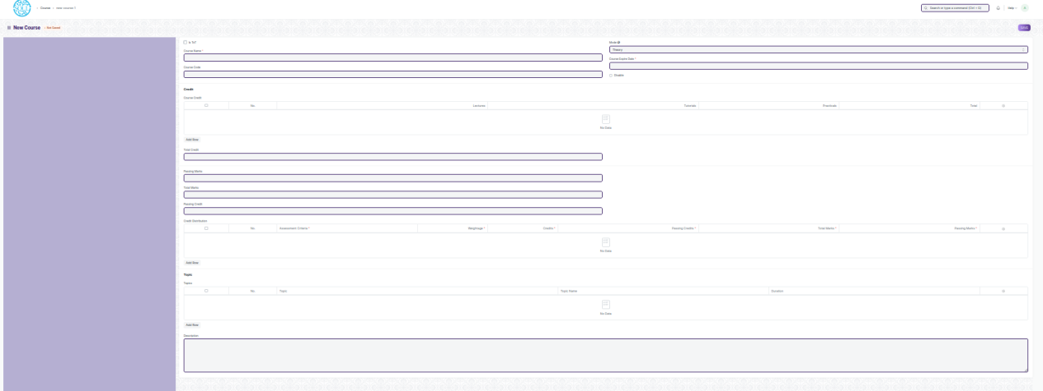

Figure 4 : Course Screen

**Field List**

The following table describes the UI fields present in this screen :

|  |  |  |  |  |  |  |
| --- | --- | --- | --- | --- | --- | --- |
| **ID** | **Field Name** | **Field Type** | **Mandatory** | **Validation/ Action** | **Remarks** | **R/N/D** |
| 1 | Course Name | Text | Yes |  |  | ( R ) Module Name |
| 2 | Is ToT | Checkbox |  | Checking this checkbox will mark the student profile that will be created as one belonging to a ToT candidate |  |  |
| 3 | Course Code | Text | Yes |  |  | ( R ) Module Code |
| 4 | Mode | Dropdown |  | Theory  Practical  Both |  |  |
| 5 | Course Expire Date | Date | Yes |  |  | ( R ) Module Expire Date |
| 6 | Disable | Checkbox |  | If Checked, then course should not be visible in any transaction. |  |  |
| **Course Credit** | | | | | | |
| 7 | Lectures | Float |  |  |  | ( D ) |
| 8 | Tutorials | Float |  |  |  | ( D ) |
| 9 | Pacticals | Float |  |  |  | ( D ) |
| 10 | Total | Float |  | Total Will be auto calculate  The sumof L, T & P |  | ( D ) |
| 11 | Total Credit | Float |  | Total Credit Will be auto calculate  the sum of L, T & P |  | ( D ) |
| 12 | Passing Marks | Float |  |  |  |  |
| 13 | Total Marks | Float |  |  |  |  |
| 14 | Passing Credit | Float |  |  |  | ( D ) |
| **Credit Distribution** | | | | | | |
| 15 | Assessment Criteria | Link Field | Yes |  |  |  |
| 16 | Weightage | Percentage | Yes |  |  |  |
| 17 | Credits | Float | Yes |  |  | ( D ) |
| 18 | Passing Credits | Float | Yes |  |  | ( D ) |
| 19 | Total Marks | Float | Yes | Weightage will be auto fetched in Total Marks |  |  |
| 20 | Passing Marks | Float | Yes |  |  |  |
| **Topic** | | | | | | |
| 21 | Topic | Link Field |  | Links with Topic Screen |  |  |
| 22 | Topic Name | Text |  | Auto fetch the Topic Name when topic is entered |  |  |
| 23 | Duration | Duration |  |  |  |  |
| 24 | Attach lesson plan | Attach |  | 1. On attachment a dialogue box will be popup where user can attach the files, take the picture with the help camera and can link any URL. 2. If photos or images attached then the size will be maximum 200 kb. |  |  |
| 25 | Action/ Add to Semester | Action Button |  | A popup will open, you need to choose the semester name, where you want to Link . |  |  |

**User: Roles & Permission**

The following table describes the users and their roles and permissions for the screens :

|  |  |  |  |  |  |  |  |  |
| --- | --- | --- | --- | --- | --- | --- | --- | --- |
| **ID** | **Role** | **Read** | **Write** | **Create** | **Delete** | **Submit** | **Cancel** | **Amend** |
| 1 | ToT coordinator/director | Yes | Yes | Yes | Yes | NA | NA | NA |
| 2 | ToT coordinator/administrator | Yes | Yes | Yes | Yes | NA | NA | NA |
| 3 | ToT assistant coordinator/trainer | Yes | No | No | No | NA | NA | NA |
| 4 | ToT candidate | Yes | No | No | No | NA | NA | NA |

### Semester

**General Description**

The following table describes overall information about this screen:

|  |  |
| --- | --- |
| **Description** | 1. A semester is individual part of a program. A semester system divides the academic year into different sessions which have various course enrollments enlisted in them. 2. For example, a program in Mechatronics can consist of 2 semesters. |
| **Navigation** | Home > Admission > Masters > Semester |
| **Pre-requisites** | 1. Department 2. Course Grade 3. Course |
| **Existing Screen Name** | Semester |
| **New Screen Name** | No change |

**Screenshot**

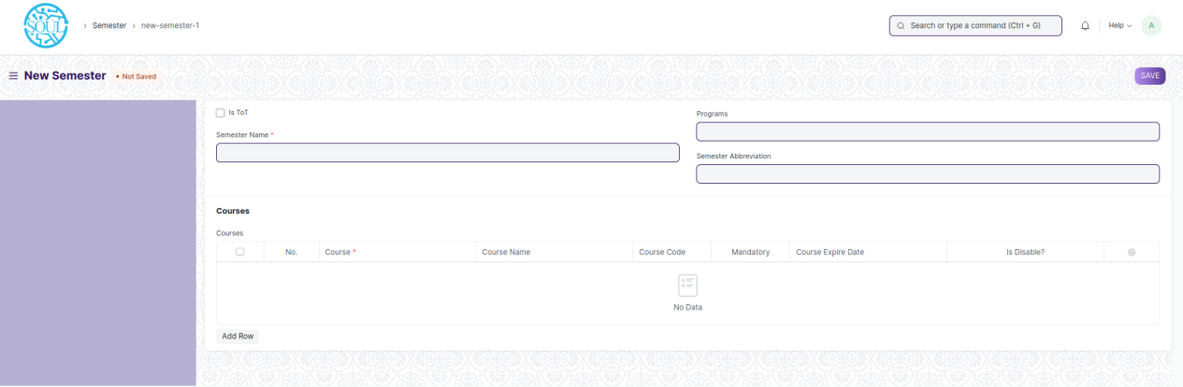Figure 5 : Semester Screen

**Field List**

The following table describes the UI fields present in this screen :

|  |  |  |  |  |  |  |
| --- | --- | --- | --- | --- | --- | --- |
| **ID** | **Field Name** | **Field Type** | **Mandatory** | **Validation/ Action** | **Remarks** | **R/N/D** |
| 1 | Semester Name | Text | Yes |  |  |  |
| 2 | Is ToT | Checkbox |  | Checking this checkbox will mark the student profile that will be created as one belonging to a ToT candidate |  |  |
| 3 | Department | Link Field |  |  |  |  |
| 4 | Programs | Link Field | Yes | Program Name will come in a drop down on the basis of Department Name. |  | ( R )Course |
| 5 | Semester Abbreviation | Text |  |  |  |  |
| **Courses Table** | Programs Abbreviation | Text | Yes |  |  | (R) Course  Abbreviation |
| 6 | Course | Link Field | Yes | Links with Course Screen |  | ( R ) Module |
| 7 | Course Name | Text |  | Auto fetched when course is entered |  | ( R ) Module |
| 8 | Course Code | Text |  | Auto fetched when course is entered |  | ( R ) (Module) |
| 9 | Mandatory | Checkbox |  |  |  |  |
| 10 | Modes | Dropdown |  | Auto fetched when course is entered |  |  |
| 11 | Course Expire Date | Date |  | Auto fetched when course is entered |  | ( R ) Module |
| 12 | Is Disable? | Checkbox |  | Auto fetched when course is entered |  |  |

**User: Roles & Permission**

The following table describes the users and their roles and permissions for the screens :

|  |  |  |  |  |  |  |  |  |
| --- | --- | --- | --- | --- | --- | --- | --- | --- |
| **ID** | **Role** | **Read** | **Write** | **Create** | **Delete** | **Submit** | **Cancel** | **Amend** |
| 1 | ToT coordinator/director | Yes | Yes | Yes | No | NA | NA | NA |
| 2 | ToT coordinator/administrator | Yes | Yes | Yes | No | NA | NA | NA |
| 3 | ToT assistant coordinator/trainer | Yes | No | No | No | NA | NA | NA |

### Topic

**General Description**

|  |  |
| --- | --- |
| **Description :** | **A Topic is a sub unit of a Module and will contain all the contents related to the topic.** |
| **Path :** | Home > Admission > Masters > Topic |
| **Pre-requisites :** |  |
| **Existing Screen Name** | Topic |
| **New Screen Name** | No change |

**Screenshot**

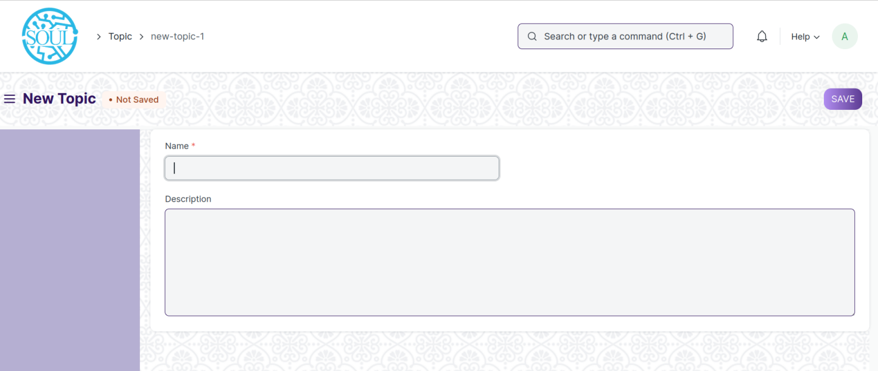Figure 6 : Topic Screen

**Field List:**

The following table describes the UI fields present in this screen :

|  |  |  |  |  |  |  |
| --- | --- | --- | --- | --- | --- | --- |
| **ID** | **Field Name** | **Field Type** | **Mandatory** | **Validation/ Action** | **Remarks** | **R/N/D** |
| 1 | Name | Data | Yes |  |  |  |
| 2 | Topic content | Table |  |  |  |  |
| 3 | Description | Small Text |  |  |  |  |
| 4 | Hero Image | Attach Image |  |  |  |  |

**User: Roles & Permission :**

The following table describes the users and their roles and permissions for the screens :

|  |  |  |  |  |  |  |  |  |
| --- | --- | --- | --- | --- | --- | --- | --- | --- |
| **ID** | **Role** | **Read** | **Write** | **Create** | **Delete** | **Submit** | **Cancel** | **Amend** |
| 1 | ToT coordinator/director | Yes | Yes | Yes | Yes | NA | NA | NA |
| 2 | ToT coordinator/administrator | Yes | Yes | Yes | Yes | NA | NA | NA |
| 3 | ToT assistant coordinator/trainer | Yes | No | No | No | NA | NA | NA |

## Admission

### 2.1 Student

**General Description**

The following table describes overall information about this screen:

|  |  |
| --- | --- |
| **Description** | 1. The Student document will hold all the data related to the student such as their personal information, Photo, Date of Birth, Address, etc. 2. This form will also contain any additional details, like the Student's Guardian and Sibling details. 3. Note : *The student is enrolled in a program when the application (Student Application) is approved. Once the enrollment is done, the Student Applicant status is updated to Admitted* |
| **Navigation** | Home > Admission > Student & Instructor > Student |
| **Pre-requisites** |  |

**Screenshot**

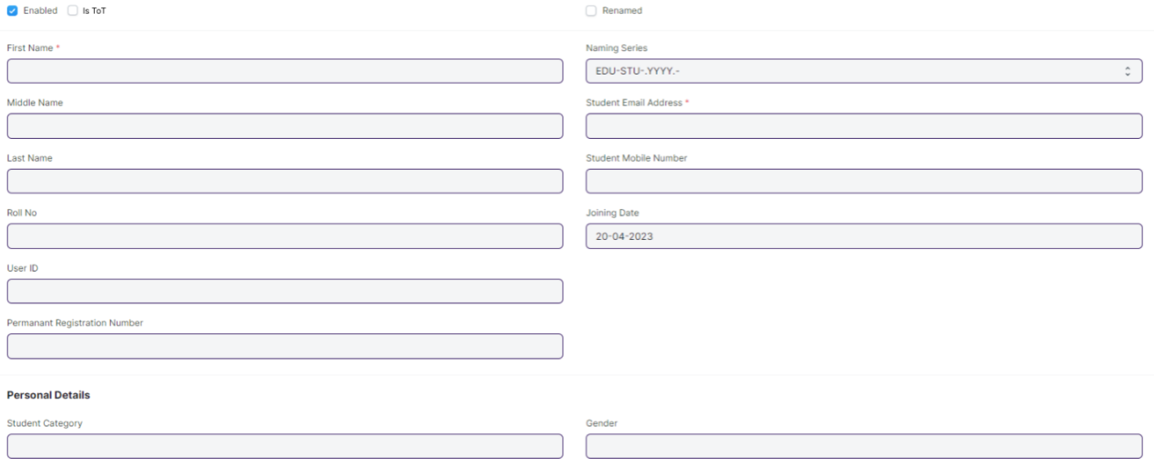

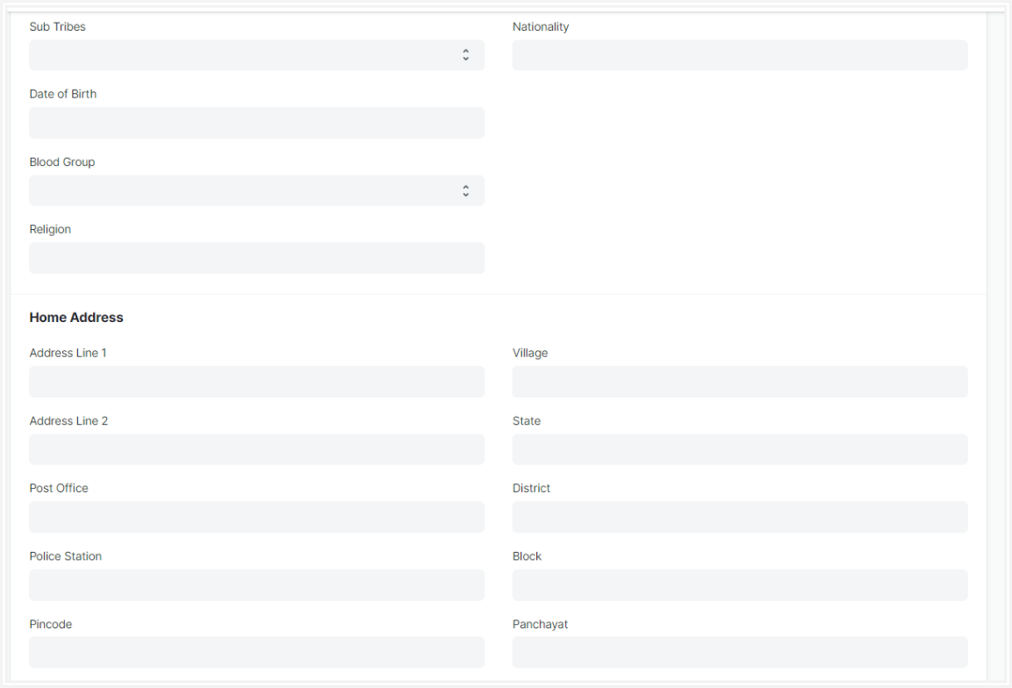

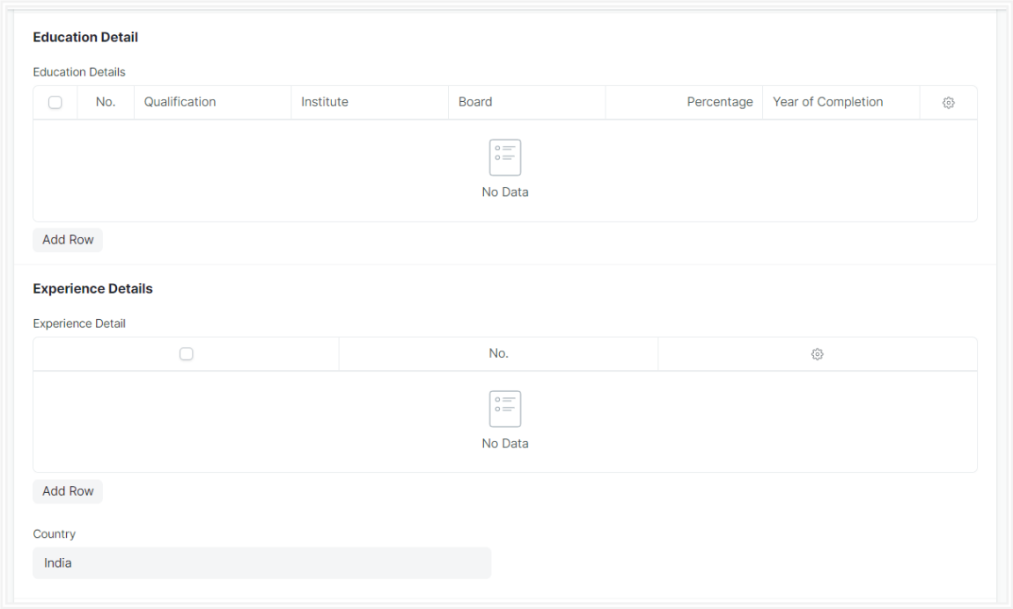

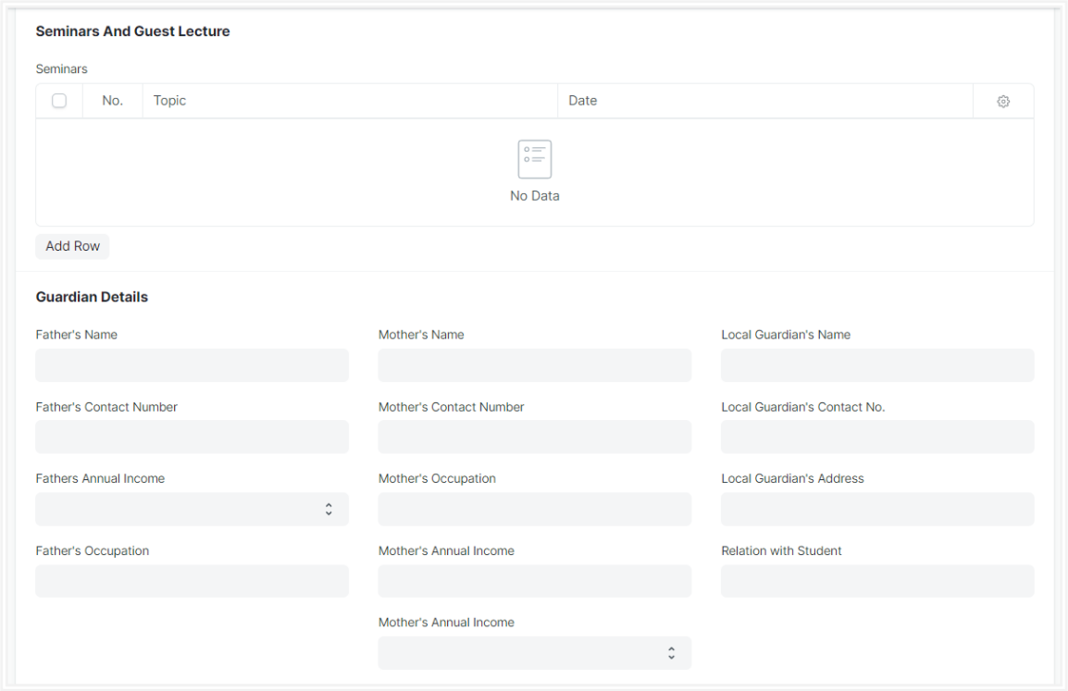

Figure 7 : Student Screen

**Field List**

The following table describes the UI fields present in this screen:

|  |  |  |  |  |  |  |
| --- | --- | --- | --- | --- | --- | --- |
| **ID** | **Field Name** | **Field Type** | **Mandatory** | **Validation / Action** | **Remarks** | **R/N/D** |
|  | Enabled | Checkbox |  | Student by default would  always be enabled.  Once user have recorded  the Student's Exit Details,  user must unchecked this box to disable the student. |  |  |
| 1 | First Name | Text | Yes |  |  |  |
| 2 | Middle Name | Text |  |  |  |  |
| 3 | Last Name | Text |  |  |  |  |
| 4 | Roll No | Text |  |  |  |  |
| 5 | User ID | Link Field |  | 1. Links to User Screen 2. After Stud approvent Applicant formed, the auto fetched the User id data in student. 3. If manually Student record created, the user need to entered the User Id. |  |  |
| 6 | Permanent Registration Number | Text |  |  |  |  |
| 7 | Naming Series | Dropdown |  | Autogenerate |  |  |
| 8 | Student Email Address | Text |  | Need to be added Email format |  |  |
| 9 | Student Mobile Number | Text |  | Restricted to 10 digits |  |  |
| 10 | Joining Date | Text |  | It is By default today's date |  |  |
| 11 | Image | Attachment |  | 1. On attachment a dialogue box will be popup where user can attach the files, take the picture with the help camera and can link any URL. 2. If photos or images attached then the size will be maximum 200 kb. |  |  |
| 12 | Student Category | Link Field |  | Links to Student Category Screen |  |  |
| 13 | Sub Tribes | Dropdown |  | 1. Kond 2. Gabri 3. Dongri 4. etc |  |  |
| 14 | Date of Birth | Date |  |  |  |  |
| 15 | Blood Group | Dropdown |  | A +ve  B +ve  AB +ve  O +ve  A -ve  B -ve  AB -ve  O -ve |  |  |
| 16 | Religion | Link |  |  |  |  |
| 17 | Gender | Link |  |  |  |  |
| 18 | Nationality | Text |  |  |  |  |
| 19 | Physically Disabled | Checkbox |  |  |  |  |
| 20 | Award Winner | Checkbox |  |  |  |  |
| 21 | Address Line 1 | Text |  |  |  |  |
| 22 | Address Line 2 | Text |  |  |  |  |
| 23 | Post Office | Text |  |  |  |  |
| 24 | Police Station | Text |  |  |  |  |
| 25 | Pincode | Text |  |  |  |  |
| 26 | Village | Text |  |  |  |  |
| 27 | State | Text |  |  |  |  |
| 28 | District | Text |  |  |  |  |
| 29 | Block | Text |  |  |  |  |
| 30 | Panchayat | Text |  |  |  |  |
| **Current Educational Details** | | | | **Auto Updated when program enrollment record is submitted for individual Students** |  |  |
| 31 | Programs | Link Field |  | Links to Program Screen, and auto fetched from program enrollment screen |  | (R) Course |
| 32 | Semesters | Link Field |  | Links to Semester Screen, and auto fetched from program enrollment screen |  |  |
| 33 | Academic Year | Link Field |  | Links to Academic Year Screen, and auto fetched from program enrollment screen |  |  |
| 34 | Academic Term | Link Field |  | Links to Academic Term Screen, and auto fetched from program enrollment screen |  |  |
| 35 | Qualification | Link Field |  | Links to Eligibility Parameter Screen |  |  |
| 36 | Institute | Text |  |  |  |  |
| 37 | Board | Text |  |  |  |  |
| 38 | Percentage/CGPA | Dropdown |  |  |  |  |
| 39 | Total Marks | Number |  |  |  |  |
| 40 | Earned Marks | Number |  |  |  |  |
| 41 | Percentage | Float |  |  |  |  |
| 42 | CGPA | Float |  |  |  |  |
| 43 | Year of Completion | Text |  |  |  |  |
| 44 | Company name | Text |  |  |  |  |
| 45 | Job profile | Text |  |  |  |  |
| 46 | Job type | Dropdown |  | 1. Permanent 2. Internship 3. Contractual 4. Non-contractual |  |  |
| 47 | Job start date | Text |  |  |  |  |
| 48 | Job end date | Text |  |  |  |  |
| 49 | Job duration | Text |  |  |  |  |
|  |  |  |  |  |  |  |
| 50 | Country | Link |  |  |  |  |
| 51 | Topic | Text |  |  |  |  |
| 52 | Activities | Dropdown |  |  |  |  |
| 53 | Description | text |  |  |  |  |
| 54 | Duration | Float |  |  |  |  |
| 55 | Department | Link |  |  |  |  |
| 56 | Academic Year | Link |  |  |  |  |
| 57 | Date | Text |  |  |  |  |
| 58 | Student Id | Text |  |  |  |  |
| 59 | Father's Name | Text |  |  |  |  |
| 60 | Father's Contact Number | Text |  |  |  |  |
| 61 | Fathers Annual Income | Text |  |  |  |  |
| 62 | Father's Occupation | Text |  |  |  |  |
| 63 | Mother's Name | Text |  |  |  |  |
| 64 | Mother's Contact Number | Text |  |  |  |  |
| 65 | Mother's Occupation | Text |  |  |  |  |
| 66 | Mother's Annual Income | Text |  |  |  |  |
| 67 | Local Guardian's Name | Text |  |  |  |  |
| 68 | Local Guardian's Contact No | Text |  |  |  |  |
| 69 | Local Guardian's Address | Text |  |  |  |  |
| 70 | Relation with Student | Text |  |  |  |  |
| 71 | Full Name | Text |  |  |  |  |
| 72 | Gender | Dropdown |  |  |  |  |
| 73 | Date of Birth | Text |  |  |  |  |
| 74 | Student Roll Number | Text |  |  |  |  |
| 75 | Contact Number | Text |  |  |  |  |
| 76 | Alumni | Checkbox |  |  |  |  |
| 77 | Program Name | Text |  |  |  |  |
| 78 | Academic Year | Text |  |  |  |  |
| 79 | Illness | Text |  |  |  |  |
| 80 | Description | Text |  |  |  |  |
| 81 | Attach | Attachment |  | 1. On attachment a dialogue box will be popup where user can attach the files, take the picture with the help camera and can link any URL. 2. If photos or images attached then the size will be maximum 200 kb. |  |  |
| 82 | Date of Leaving | Date |  |  |  |  |
| 83 | Leaving Certificate Number | Text |  |  |  |  |
| 84 | Reason For Leaving | Text |  |  |  |  |
| 85 | Mentor Allocation | Link Field |  |  |  |  |
| 86 | Document Name | Link Field |  |  |  |  |
| 87 | Mandatory | Checkbox |  |  |  |  |
| 88 | Attach | Attachment |  | 1. On attachment a dialogue box will be popup where user can attach the files, take the picture with the help camera and can link any URL. 2. If photos or images attached then the size will be maximum 200 kb. |  |  |

**Users: Roles & Permission**

The following table describes the users and their roles and permissions for the screens :

|  |  |  |  |  |  |  |  |  |
| --- | --- | --- | --- | --- | --- | --- | --- | --- |
| **ID** | **Role** | **Read** | **Write** | **Create** | **Delete** | **Submit** | **Cancel** | **Amend** |
| 1 | ToT coordinator/director | Yes | Yes | Yes | Yes | NA | NA | NA |
| 2 | ToT coordinator/administrator | Yes | Yes | Yes | Yes | NA | NA | NA |
| 3 | ToT assistant coordinator/trainer | Yes | Yes | Yes | Yes | NA | NA | NA |

### 2.2 Program Enrollment

**General Description**

The following table describes overall information about this screen:

|  |  |
| --- | --- |
| **Description** | 1. Program Enrollment is the record of enrollment of a student in a given program and chosen courses for a particular Academic Term. 2. To ensure that students are associated with a particular program in the system, their Program Enrollment must be created. The mandatory course in that program is automatically filled in the Enrolled Courses table while the elective or optional courses can be selected manually. 3. If the student has applied online for the admission in a particular Program and the application is approved, then the Program Enrollment can be created from within the Student Applicant record via clicking on the Enroll button. |
| **Navigation** | Home > Education > Admission > Program Enrollment |
| **Pre-requisites** | Student  Fee Structure  Student Batch |
| **Existing Screen Name** | Program Enrollment |
| **New Screen Name** | Course Enrollment |

**Screenshot**

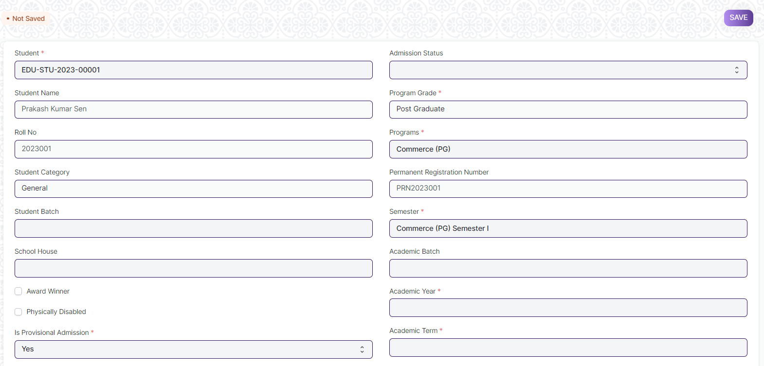Figure 9 : Program Enrollment Screen

**Field List**

The following table describes the UI fields present in this screen :

|  |  |  |  |  |  |  |
| --- | --- | --- | --- | --- | --- | --- |
| **ID** | **Field Name** | **Field Type** | **Mandatory** | **Validation / Action** | **Remarks** | **R/N/D** |
| 1 | Student | Link Field | Yes | Link Fields to master screen Student, auto fetched when clicked enrolled button from student or student Applicant screen. |  |  |
| 2 | Student Name | Read Only |  | Auto fetched when student id is inputted. |  |  |
| 3 | Roll No | Text |  |  |  |  |
| 4 | Gender | Link Field |  | Link Fields to master screen Gender, auto fetched when clicked enrolled connection button from student screen or enroll button from student applicant screen. |  |  |
| 5 | Student Category | Link Field |  | Link Fields to master screen Student Category, auto fetched when clicked enrolled connection button from student screen or enroll button from student applicant screen |  |  |
| 6 | Student Batch | Link Field |  | Link Fields to master screen Student Batch Name |  |  |
| 7 | School House | Link Field |  | Link Fields to master screen School House |  |  |
| 10 | Physically Disabled | Checkbox |  |  |  |  |
| 12 | Is Provisional Admission | Dropdown | Yes | Yes  No |  |  |
| 14 | Admission Status | Dropdown |  | Provisional Admission  Admitted |  |  |
| 16 | Program Grade | Link Field |  | Link Fields to master screen Program Grade |  | (R) Course Grade |
| 17 | Programs | Link Field |  | Link Fields to master screen Programs and filtered on the basis of program grade |  | (R) Courses |
| 18 | Permanent Registration Number | Text |  |  |  |  |
| 19 | Program | Link Field | Yes | Link Fields to master screen Semester and filtered on the basis of programs |  | (R) Semester |
| 20 | Academic Batch | Text |  |  |  | (D) |
| 21 | Academic Year | Link Field | Yes | Link Fields to master screen Academic Year auto fetched when clicked enrolled connection button from student screen. And enroll button form student applicant screen. |  |  |
| 22 | Academic Term | Link Field |  | Link Fields to master screen Academic Term |  |  |
| 23 | Year End Date | Date |  |  |  |  |
| 24 | Enrollment Date | Date | Yes |  |  |  |
| 25 | Seat Reservation Type | Link Field |  | Link Fields to master screen Seat Reservation Type and fetched on the basis student category wise seat reservation |  |  |
| 26 | Available seats | Number |  | Auto fetched from Student admission screen child table Reservation distribution table. |  |  |
| 27 | Boarding Student | Checkbox |  |  |  |  |
| **Enrolled courses** | | | | | | |
| 29 | **Courses** | Table |  | Description of the table is given below |  | (R) Modules |
| **Transportation** | | | | | | |
| 31 | Mode of Transportation |  |  |  |  |  |
| 32 | Vehicle/Bus Number |  |  |  |  |  |
| 34 | Due Date | Date |  |  |  |  |
| 35 | **Fee Structure Item** | Table |  | 1. Once program enrollment record submitted for a particular student then in back-end the fees record for that particular student will created and then the student need to pay their fees from the Fees screen.   2. Description of this table is given below. |  |  |
| 37 | Image | Attach Image |  | 1. On attachment a dialogue box will be popup where user can attach the images, take the picture with the help camera. 2. If photos or images attached then the size will be maximum 200 kb. |  |  |
| 38 | **Academic Calendar** | Table |  | Description of this table is given below. |  |  |
| 42 | Voucher No. | Data |  |  |  |  |
| 43 | Company | Data |  |  |  |  |
| 44 | Submit | | | On submit the record the course enrollment auto created and student will be enrolled on those courses which are present in **course** child table |  |  |

|  |  |  |  |  |  |  |
| --- | --- | --- | --- | --- | --- | --- |
| **Program Enrollment Course** | | | | | | |
| **ID** | **Field Name** | **Field Type** | **Validation/Action** | **Mandatory** | **Remarks** | **R/N/D** |
| 1 | Course | Link Field |  | Yes | Link Fields to master screen Course, and those courses will be visible which are linked with inputted semester | (R) Module |
| 2 | Course Code | Text |  |  |  | (R) Module Code |
| 3 | Course Name | Text |  |  |  | (R) Module Name |
| 4 | Instructor | Link Field |  |  | Link Fields to master screen Instructor | (R) Trainer |
| 5 | Credit Allocation | Button |  |  |  | (D) |

|  |  |  |  |  |  |  |
| --- | --- | --- | --- | --- | --- | --- |
| **Fee Structure Item** | | | | | | |
| **ID** | **Field Name** | **Field Type** | **Validation/Action** | **Mandatory** | **Remarks** | **R/N/D** |
| 1 | Student Category | Link Field |  |  | Link Fields to master screen Student Category |  |
| 2 | Fee Structure | Link Field |  | Yes | Link Fields to master screen Fee Structure |  |
| 3 | Amount | Currency |  |  |  |  |
| 4 | Due Date | Date |  | Yes |  |  |

|  |  |  |  |  |  |  |
| --- | --- | --- | --- | --- | --- | --- |
| **Academic Calendar** | | | | | | |
| **ID** | **Field Name** | **Field Type** | **Validation/Action** | **Mandatory** | **Remarks** | **R/N/D** |
| 1 | Academic Events | Link Field |  | Yes | Link Fields to master screen Academic Events, events will fetch w.r.t Academeic Calendar Template |  |
| 2 | Start Date | Date |  | Yes | Start date will fetch w.r.t Academeic Calendar Template |  |
| 3 | End Date | Date |  | Yes | End date will fetch w.r.t Academeic Calendar Template |  |
| 4 | Duration | Number |  |  | Duration will fetch w.r.t Academeic Calendar Template |  |

**User: Roles & Permission**

The following table describes the users and their roles and permissions for the screens :

|  |  |  |  |  |  |  |  |  |
| --- | --- | --- | --- | --- | --- | --- | --- | --- |
| **ID** | **Role** | **Read** | **Write** | **Create** | **Delete** | **Submit** | **Cancel** | **Amend** |
| 1 | ToT coordinator/director | Yes | Yes | Yes | Yes | Yes | Yes | Yes |
| 2 | ToT coordinator/administrator | Yes | Yes | Yes | Yes | Yes | Yes | Yes |
| 3 | ToT assistant coordinator/trainer | Yes | Yes | Yes | Yes | Yes | Yes | Yes |
| 4 | ToT candidate | No | No | No | No | No | No | No |

## 

### 2.3 Course Enrollment

**General Description**

The following table describes overall information about this screen:

|  |  |
| --- | --- |
| **Description** | 1. Course Enrollment is the record of enrollment of a student in a given program and chosen courses for a particular Academic Term. 2. To ensure that students are associated with a particular program in the system, their Course Enrollment must be created/auto-generated. The mandatory course in that program is automatically filled in the Enrolled Courses table while the elective or optional courses can be selected manually. 3. If the student has applied online for the admission in a particular Program and the application is approved, then the Course Enrollment is auto-created from within the Program Enrollment record. |
| **Navigation** | Home > Admission > Application & Enrollment > Course Enrollment |
| **Pre-requisites** | Program Enrollment |
| **Existing Screen Name** | Course Enrollment |
| **New Screen Name** | Module Enrollment |

**Screenshot**

Figure 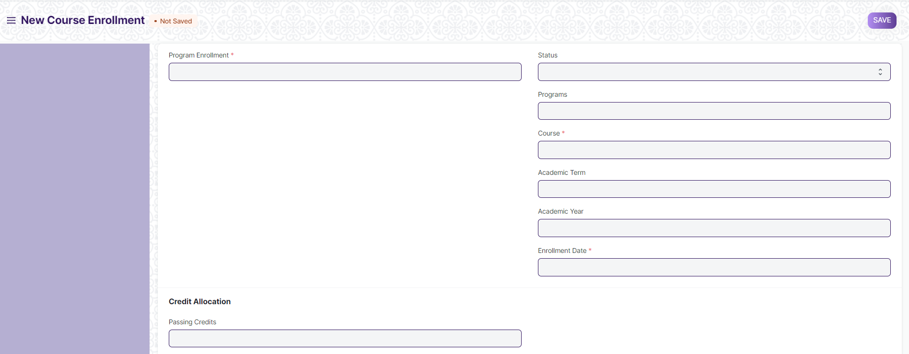10 : Course Enrollment Screen

**Field List**

The following table describes the UI fields present in this screen :

|  |  |  |  |  |  |  |
| --- | --- | --- | --- | --- | --- | --- |
| **ID** | **Field Name** | **Field Type** | **Validation/Action** | **Mandatory** | **Remarks** | **R/N/D** |
| 1 | Program Enrollment | Link Field | Link Fields to the master screen Program Enrollment | Yes |  | (R) Course Enrollment |
| 2 | Student | Link Field | Link Fields to the master screen Student | Yes |  |  |
| 3 | Student Name | Text |  |  |  |  |
| 4 | Roll No | Text |  |  |  |  |
| 5 | Registration Number | Text |  |  |  |  |
| 6 | Status | Dropdown |  |  |  |  |
| 7 | Programs | Link Field | Link Fields to the master screen Programs |  |  | ( R ) Course |
| 8 | Semester | Link Field | Link Fields to the master screen Program |  |  |  |
| 9 | Course | Link Field | Link Fields to the master screen Course | Yes |  | (R) Module |
| 10 | Course Name | Text |  |  |  | (R) Module Name |
| 11 | Course Code | Text |  |  |  | (R) Module Code |
| 12 | Academic Term | Link Field | Link Fields to the master screen Academic Term |  |  |  |
| 13 | Academic Year | Link Field | Link Fields to the master screen Academic Year |  |  |  |
| 14 | Enrollment Date | Date |  | Yes |  |  |
| 15 | Credit Allocation | Label |  |  |  | (D) |
| 16 | Total Credits | Float |  |  |  | (D) |
| 17 | Passing Credits | Float |  |  |  | (D) |
| 18 | **Credit distribution** | **Table** |  |  |  |  |
| 19 | Grading Scale | Link Field | Link Fields to the master screen Grading Scale |  |  |  |
| 20 | Total Course Marks | Float |  |  |  | (R) Total Module Marks |
| 21 | Course Passing Marks | Float |  |  |  | (R) Module Passing Marks |

|  |  |  |  |  |  |  |
| --- | --- | --- | --- | --- | --- | --- |
| **Credit Distribution List** | | | | | | |
| **ID** | **Field Name** | **Field Type** | **Validation/Action** | **Mandatory** | **Remarks** | **R/N/D** |
| 1 | Assessment Criteria | Link Field |  | Yes | Link Fields to master screen Assessment Criteria |  |
| 2 | Weightage | Percent |  | Yes | Weightage need to be maximum 100 |  |
| 3 | Credits | Float |  | Yes |  | (D) |
| 4 | Passing Credits | Float |  | Yes |  | (D) |
| 5 | Total Marks | Float |  | Yes |  |  |
| 6 | Passing Marks | Float |  | Yes |  |  |

|  |  |  |  |  |  |  |
| --- | --- | --- | --- | --- | --- | --- |
| **Topic** | | | | | | |
| **ID** | **Field Name** | **Field Type** | **Validation/Action** | **Mandatory** | **Remarks** | **R/N/D** |
| 1 | Topic | Link Field |  | Yes | Link Fields to master screen Topic, and auto fetched from the course screen, w.r.t the course field data. | ( R ) Sub Module |
| 2 | Topic Name | Text |  | Yes | auto fetched from the course screen, w.r.t the course field data. | ( R ) Sub Module Name |
| 3 | Duration | Time |  | Yes | auto fetched from the course screen, w.r.t the course field data. |  |
| 4 | Description | Long Text |  | Yes | auto fetched from the course screen, w.r.t the course field data. | (N) |
| 5 | Attachment | Attach |  |  | 1. auto fetched from the course screen, w.r.t the course field data. 2. On attachment a dialogue box will be popup where user can attach the files, take the picture with the help camera and can link any URL. 3. If photos or images attached then the size will be maximum 200 kb. |  |

**User: Roles & Permission**

The following table describes the users and their roles and permissions for the screens :

|  |  |  |  |  |  |  |  |  |
| --- | --- | --- | --- | --- | --- | --- | --- | --- |
| **ID** | **Role** | **Read** | **Write** | **Create** | **Delete** | **Submit** | **Cancel** | **Amend** |
| 1 | ToT coordinator/director | Yes | Yes | Yes | Yes | NA | NA | NA |
| 2 | ToT coordinator/administrator | Yes | Yes | Yes | Yes | NA | NA | NA |
| 3 | ToT assistant coordinator/trainer | Yes | Yes | Yes | Yes | NA | NA | NA |

### 2.4 ToT candidate list

**General Description**

|  |  |
| --- | --- |
| **Description** | This screen is used to enter and maintain the details of eligible candidates for the ToT Program.  This screen contains the list of all candidates that could ever qualify for TOT under DTET |
| **Navigation** | NA |
| **Pre-requisites** | NA |
| **Existing Screen Name** | ToT candidate list |
| **New Screen Name** | No change |

### **Screenshot**

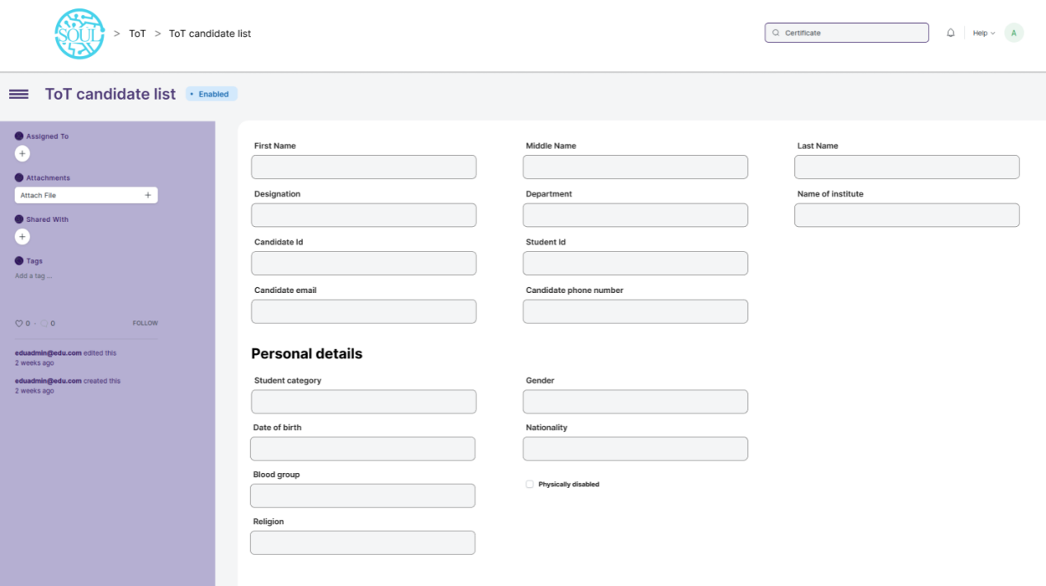

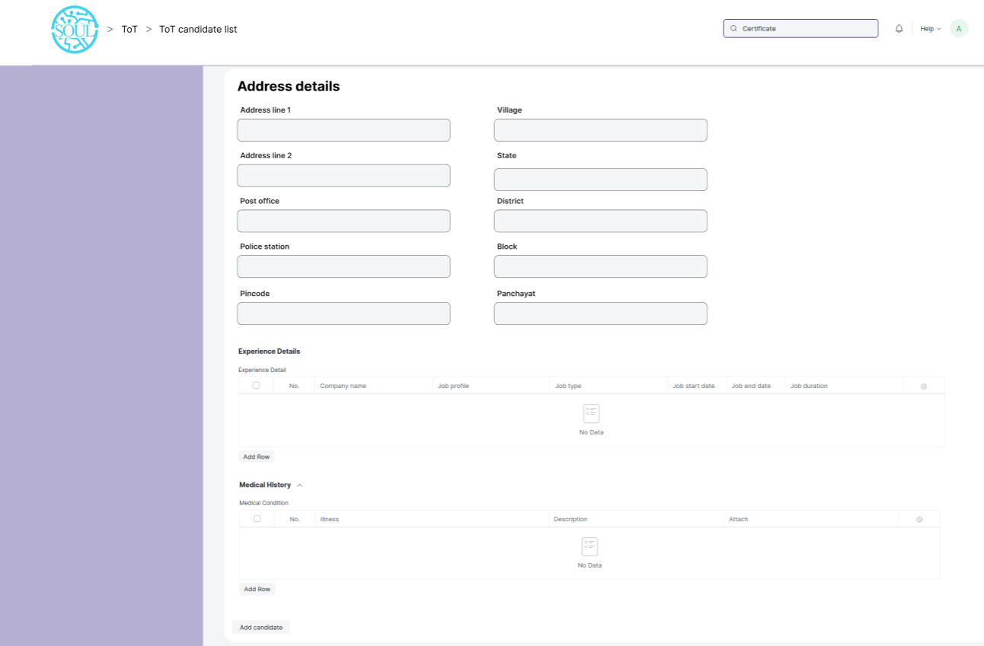

Figure 30 : ToT candidate list Screen

### **Field List**

The “ToT candidate list” screen shall consist of the following fields:

|  |  |  |  |  |  |  |
| --- | --- | --- | --- | --- | --- | --- |
| ToT candidate list | | | | | | |
| **ID** | **Field Label** | **Field Type** | **Mandatory** | **Validation/Action** | **Remarks** | **R/N/D** |
| 1 | First Name | Text | Yes |  |  |  |
| 2 | Middle Name | Text |  |  |  |  |
| 3 | Last Name | Text |  |  |  |  |
| 4 | Designation | Text |  |  |  |  |
| 5 | Department | Text |  |  |  |  |
| 6 | Name of institute | Text |  |  |  |  |
| 7 | Candidate ID | Text |  |  |  |  |
| 8 | Student ID | Text |  |  |  |  |
| 9 | Candidate email | Text |  |  |  |  |
| 10 | Candidate phone number | Text |  |  |  |  |
| **Personal Details** | | | | | | |
| 11 | Student Category | Link Field |  | Links to Student Category Screen |  |  |
| 12 | Sub Tribes | Dropdown |  | 1. Kond   2. Gabri  3. Dongri  4. etc |  |  |
| 13 | Date of Birth | Date |  |  |  |  |
| 14 | Blood Group | Dropdown |  | A +ve  B +ve  AB +ve  O +ve  A -ve  B -ve  AB -ve  O -ve |  |  |
| 15 | Religion | Link |  |  |  |  |
| 16 | Gender | Link |  |  |  |  |
| 17 | Nationality | Text |  |  |  |  |
| 18 | Physically Disabled | Checkbox |  |  |  |  |
| **Address details** | | | | | | |
| 19 | Address Line 1 | Text |  |  |  |  |
| 20 | Address Line 2 | Text |  |  |  |  |
| 21 | Post Office | Text |  |  |  |  |
| 22 | Police Station | Text |  |  |  |  |
| 23 | Pincode | Text |  |  |  |  |
| 24 | Village | Text |  |  |  |  |
| 25 | State | Text |  |  |  |  |
| 26 | District | Text |  |  |  |  |
| 27 | Block | Text |  |  |  |  |
| 28 | Panchayat | Text |  |  |  |  |
| **Experience Details** | | | | | | |
| 44 | Company name | Text |  |  |  |  |
| 45 | Job profile | Text |  |  |  |  |
| 46 | Job type | Dropdown |  | 1. Permanent   2. Internship  3. Contractual  4. Non-contractual |  |  |
| 47 | Job start date | Text |  |  |  |  |
| 48 | Job end date | Text |  |  |  |  |
| 49 | Job duration | Text |  |  |  |  |
|  |  |  |  |  |  |  |
| 50 | Country | Link |  |  |  |  |
| **Medical History** | | | | | | |
| 79 | Illness | Text |  |  |  |  |
| 80 | Description | Text |  |  |  |  |
| 81 | Attach | Attachment |  | 1. On attachment a dialogue box will be popup where user can attach the files, take the picture with the help camera and can link any URL. 2. If photos or images attached then the size will be maximum 200 kb. |  |  |

### **User: Roles & Permission**

The following table describes the users and their roles and permissions for the screens :

|  |  |  |  |  |  |  |  |  |
| --- | --- | --- | --- | --- | --- | --- | --- | --- |
| **ID** | **Role** | **Read** | **Write** | **Create** | **Delete** | **Submit** | **Cancel** | **Amend** |
| 1 | ToT coordinator/director | Yes | Yes | Yes | Yes | NA | NA | NA |
| 2 | ToT coordinator/administrator | Yes | Yes | Yes | No | NA | NA | NA |
| 3 | ToT assistant coordinator/trainer | Yes | No | No | No | NA | NA | NA |

### 2.5 ToT candidate selection

**General Description**

|  |  |
| --- | --- |
| **Description** | This screen is used to select and maintain list of candidates chosen for a particular ToT training program by WSC or DTET. |
| **Navigation** | NA |
| **Pre-requisites** | 1. ToT candidate list |
| **Existing Screen Name** | ToT candidate selection |
| **New Screen Name** | No change |

### **Screenshot**

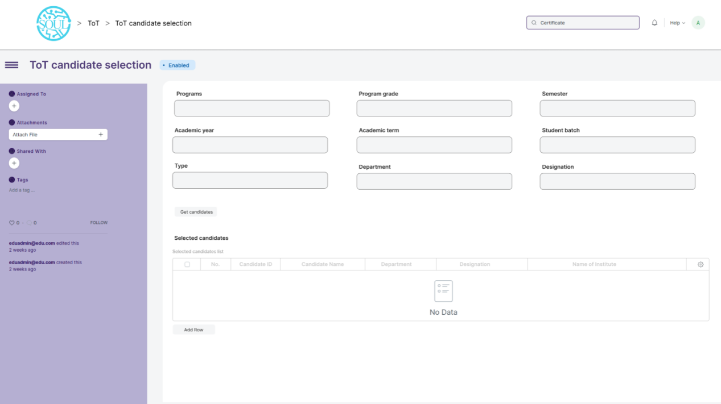

Figure 31 : ToT candidate selection

### **Field List**

The “ToT candidate selection” screen shall consist of the following fields:

|  |  |  |  |  |  |  |
| --- | --- | --- | --- | --- | --- | --- |
| **ToT candidate selection** | | | | | | |
| **ID** | **Field Label** | **Field Type** | **Mandatory** | **Validation/Action** | **Remarks** | **R/N/D** |
| 1 | Programs | Text Field | Yes |  |  |  |
| 2 | Program grade | Text Field |  |  |  |  |
| 3 | Semester | Text Field |  |  |  |  |
| 4 | Academic year | Link |  | Links to Academic Year Screen |  |  |
| 5 | Academic term | Link |  | Links to Academic Term Screen |  |  |
| 6 | Student batch | Link |  | Links to Student Batch Screen |  |  |
| 7 | Candidate ID | Text Field |  |  |  |  |
| 8 | Type | Text Field |  |  |  |  |
| 9 | Department | Link |  |  |  |  |
| 10 | Designation | Text Field |  |  |  |  |
| 11 | Candidate ID | Link Field |  | Links to Student Screen |  |  |
| 12 | Candidate name | Text Field |  | Auto fetched from Student screen |  |  |
| 13 | Department | Text Field |  | Auto fetched from Student screen |  |  |
| 14 | Designation | Text Field |  | Auto fetched from Student screen |  |  |
| 15 | Name of institute | Text Field |  | Auto fetched from Student screen |  |  |

### **User: Roles & Permission**

The following table describes the users and their roles and permissions for the screens :

|  |  |  |  |  |  |  |  |  |
| --- | --- | --- | --- | --- | --- | --- | --- | --- |
| **ID** | **Role** | **Read** | **Write** | **Create** | **Delete** | **Submit** | **Cancel** | **Amend** |
| 1 | ToT coordinator/director | Yes | Yes | Yes | Yes | NA | NA | NA |
| 2 | ToT coordinator/administrator | Yes | Yes | Yes | No | NA | NA | NA |
| 3 | ToT assistant coordinator/trainer | Yes | No | No | No | NA | NA | NA |

### 2.6 ToT candidate reporting

**General Description**

|  |  |
| --- | --- |
| **Description** | This screen is used for marking a candidate/trainee as present after they have reported on the day of reporting |
| **Navigation** | NA |
| **Pre-requisites** | 1. ToT candidate selection |
| **Existing Screen Name** | ToT candidate reporting |
| **New Screen Name** | No change |

### **Screenshot**

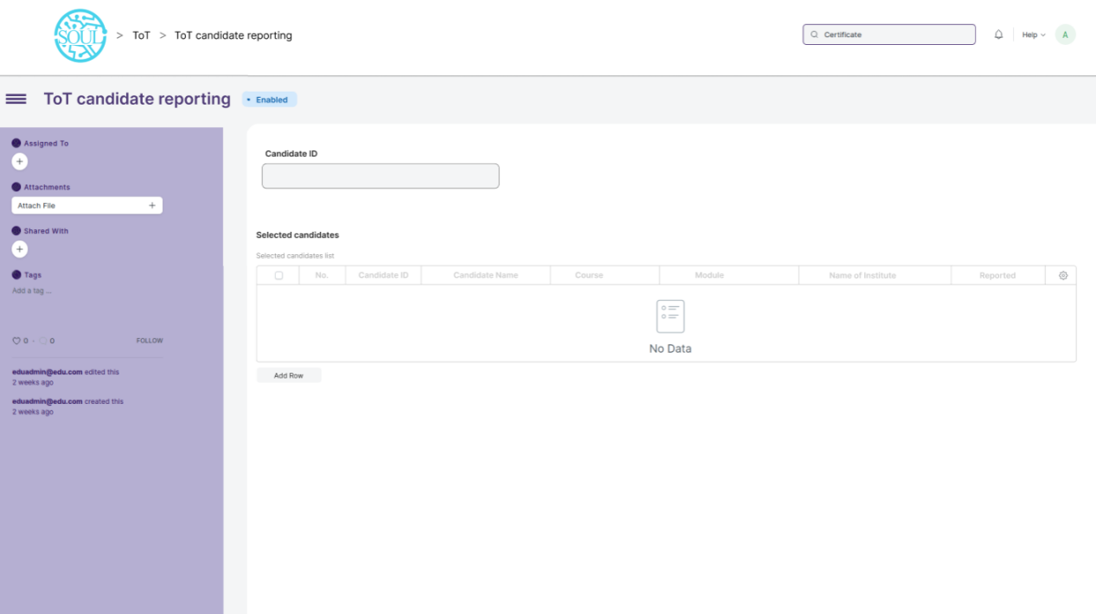

Figure 32 : ToT candidate reporting

### **Field List**

The “ToT candidate reporting” screen shall consist of the following fields:

|  |  |  |  |  |  |  |
| --- | --- | --- | --- | --- | --- | --- |
| **ID** | **Field Label** | **Field Type** | **Validation/Actions** | **Mandatory** | **Remarks** | **R/N/D** |
| 1 | Candidate ID | Link Field |  | Links to Student Screen |  |  |

|  |  |  |  |  |  |  |
| --- | --- | --- | --- | --- | --- | --- |
| Personal Detiails | | | | | | |
| ID | Field Label | Field Type | Validation/Actions | Mandatory | Remarks | R/N/D |
| 1 | Candidate ID | Link Field |  | Yes |  |  |
| 2 | Candidate name | Text |  |  |  |  |
| 3 | Department | Text |  |  |  |  |
| 4 | Designation | Text |  |  |  |  |
| 5 | Name of institute | Text |  |  |  |  |
| 6 | Reported | Checkbox |  |  |  |  |

### **User: Roles & Permission**

The following table describes the users and their roles and permissions for the screens :

|  |  |  |  |  |  |  |  |  |
| --- | --- | --- | --- | --- | --- | --- | --- | --- |
| **ID** | **Role** | **Read** | **Write** | **Create** | **Delete** | **Submit** | **Cancel** | **Amend** |
| 1 | ToT coordinator/director | Yes | Yes | Yes | Yes | NA | NA | NA |
| 2 | ToT coordinator/administrator | Yes | Yes | Yes | No | NA | NA | NA |
| 3 | ToT assistant coordinator/trainer | Yes | No | No | No | NA | NA | NA |

## 

## Academics

### 3.1 Student Group

**General Description**

The following table describes overall information about this screen:

|  |  |
| --- | --- |
| **Description** | 1. Student group is a collection of students who share common characteristics or attributes. 2. These characteristics may include factors such as the students' academic level, course of study, program of study, or other specific criteria used to group students together 3. The Student Group allows you to create a group of students for different classes for the ongoing Academic Year. 4. User will fill out the necessary information for the student group, such as a name for the group,batch,exam declaration,course ,mentor-mentee and the criteria that will be used to add students to the group for creation of student group. |
| **Navigation** | Home > Academics > Group & Schedules > Student Group |
| **Pre-requisites** | 1. Student 2. Program Enrollment 3. Course Enrollment 4. Student Batch Name 5. Student Category 6. Instructor 7. Exam Declaration |

**Screenshot**

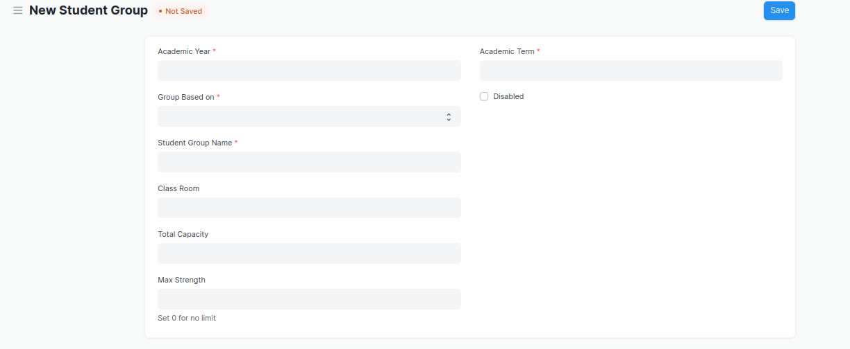

Figure 8 :Student Group screen

**Field List**

The following table describes the UI fields present in this screen :

|  |  |  |  |  |  |  |
| --- | --- | --- | --- | --- | --- | --- |
| **ID** | **Field Name** | **Field Type** | **Validation/Action** | **Mandatory** | **Remarks** | **R/N/D** |
| 1 | Academic Year | Link Field | Value Fetched From the Academic Year list and will show in a drop down. User will select one of them. | Yes |  |  |
| 2 | Group Based on | Drop down | Options : Batch Course Activity  Mentor Communication | Yes |  | (D)Combined Course |
| 3 | Student Group | Text | User will give input | Yes |  |  |
| 4 | Max Strength | Number | User will give input |  |  |  |
| 5 | Academic Term | Link Field | Link Field to Academic Term Screen and filtered applied w.r.t Academic Year |  |  |  |
| 6 | Program | Link Field | Value will be fetched from Program list in a drop down.User will select one value. |  |  | ( R ) Course |
| 7 | Batch | Link Field | Batch field will be visible if user select student group based upon batch |  |  |  |
| 8 | Student Category | Link Field | Value will be fetched from Student Category list in drop down. User will select one value. |  |  |  |
| 9 | Course | Link Field | Value will be fetched from course list , and course field will be visible when a user select group based on courses. |  |  | ( R ) Module |
| 10 | Disabled | Check box | If Checked, the student group record will not be able to visible in any respective transaction |  |  |  |
| 11 | Get Students | Button | 1. User will click the Get Students Button.   2. On click list of students with respect to the course will auto fetched in the students table |  |  |  |
| 12 | **Students** | Table | On clicking Get students button, all the students will be fetched according to the inputted parameters. And the description of the table is given below. |  |  |  |
| 13 | **Instructors** | Table | * Instructor list need to be selected according to the inputted parameters . * when student group based on course selected then only those instructor list will be on drop down w.r.t. the entered course. * Description of the table is given below. |  |  | ( R )Trainer |

|  |  |  |  |  |  |  |
| --- | --- | --- | --- | --- | --- | --- |
| **Student Group Student** | | | | | | |
| **ID** | **Field Name** | **Field Type** | **Validation/Action** | **Mandatory** | **Remarks** | **R/N/D** |
| 1 | Student | Link Field | Those students will come who are belongs to the particular course, semester and In group based up on activity and mentor communication, user needs to manually entered the students. | Yes |  |  |
| 2 | Student Name | Text | Student Name will auto fetched when student Id fetched in student Field |  |  |  |
| 3 | Group Roll Number | Number | Roll will auto create |  |  |  |
| 4 | Active | Check box | If unchecked then this Student will not visible in any transaction |  |  |  |

|  |  |  |  |  |  |  |
| --- | --- | --- | --- | --- | --- | --- |
| **Student Group Instructor** | | | | | | |
| **ID** | **Field Name** | **Field Type** | **Validation/Action** | **Mandatory** | **Remarks** | **R/N/D** |
| 1 | Instructors | Link Field | Value will fetch from Instructor list.User will select value. | Yes |  | (R) Trainer |
| 2 | Instructor Name | Read only | After selecting the instructor id , this value will be auto filled. |  |  | (R) Trainer Name |
| 3 | Course | Link Field | If course wise group created, then those course will come whose name selected in the above course field | Yes |  | (R) Module |

**Users: Roles and Permissions**

The following table describes the users and their roles and permissions for the screens :

|  |  |  |  |  |  |  |  |  |
| --- | --- | --- | --- | --- | --- | --- | --- | --- |
| **ID** | **Role** | **Read** | **Write** | **Create** | **Delete** | **Submit** | **Cancel** | **Amend** |
| 1 | ToT coordinator/director | Yes | Yes | Yes | Yes | NA | NA | NA |
| 2 | ToT coordinator/administrator | Yes | Yes | Yes | Yes | NA | NA | NA |
| 3 | ToT assistant coordinator/trainer | Yes | Yes | Yes | Yes | NA | NA | NA |

### 3.2 Instructor

**General Description**

The following table describes overall information about this screen:

|  |  |
| --- | --- |
| **Description** | 1. An instructor is a teacher, tutor, or a professor who will be responsible for teaching a particular topic or course to the students. 2. This screen will be used to maintain the Instructor Log in the form of a list of topics/courses covered by the Instructor. This log will have the entire history of the courses taught by the Instructor. |
| **Navigation** | Home > Admission > Student & Instructor > Instructor |
| **Pre-requisites** | 1. User 2. Employee 3. Department 4. Programs 5. Semester 6. Course 7. Academic Year 8. Academic Term |

**Screenshot**

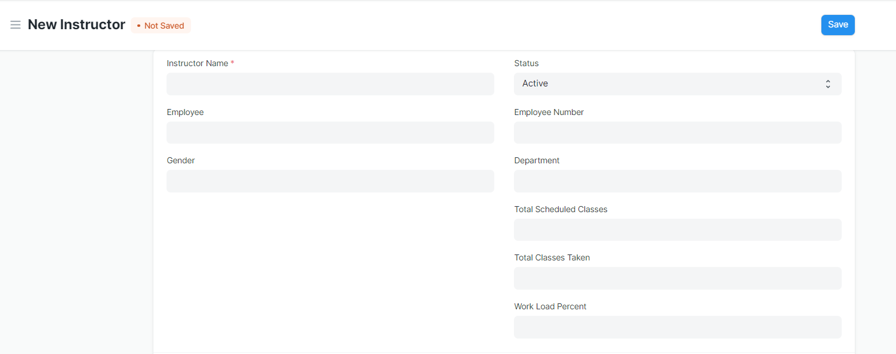

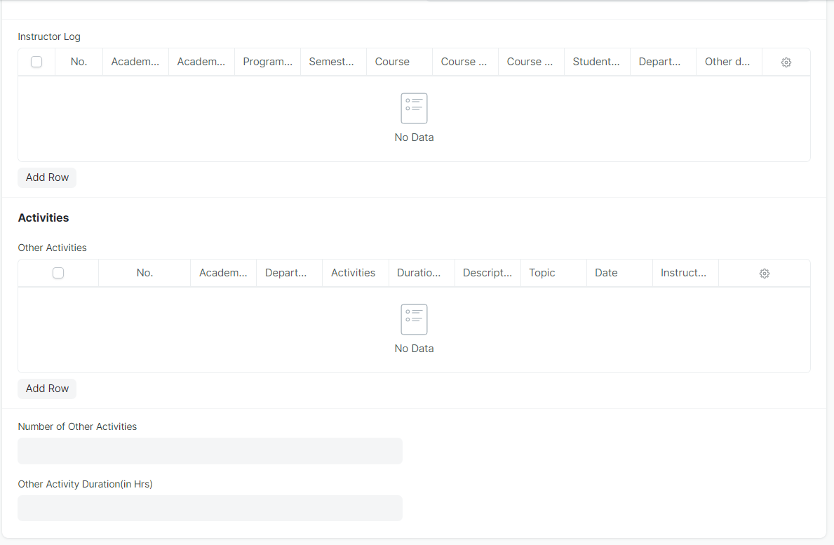

Figure 11 : Instructor Screen

**Field List**

The following table describes the UI fields present in this screen :

|  |  |  |  |  |  |  |
| --- | --- | --- | --- | --- | --- | --- |
| **ID** | **Field Name** | **Field Type** | **Mandatory** | **Validation/Action** | **Remarks** | **R/N/D** |
| 1 | Instructor Name | Text | Yes | Auto fetch the detail when employee id entered |  | (R) Trainer Name |
| 2 | Employee | Link Field |  | Linked to Employee Screen |  |  |
| 3 | Gender | Link Field |  | Auto fetch the detail when employee id entered |  |  |
| 4 | Status | Dropdown |  |  |  |  |
| 5 | Naming Series | Dropdown |  |  |  |  |
| 6 | Employee Number | Text |  | Auto fetch the detail when employee id entered |  |  |
| 7 | Department | Link Field |  | Auto fetch the detail when employee id entered |  |  |
| 8 | Total Scheduled Classes | Number |  |  |  |  |
| 9 | Total Classes Taken | Number |  |  |  |  |
| 10 | Work Load Percent | Float |  |  |  |  |
| 11 | Image | Attach Image |  | 1. On attachment a dialogue box will be popup where user can attach the image, take the picture with the help camera and can link any URL. 2. If photos or images attached then the size will be maximum 200 kb. |  |  |
| 12 | Academic Year | Link Field | Yes |  |  |  |
| 13 | Academic Term | Link Field |  | Academic Term is filtered on the basis of Academic Year |  |  |
| 14 | Department | Link Field |  |  |  |  |
| 15 | Programs | Link Field | Yes |  |  | (R) Course |
| 16 | Semester | Link Field | Yes | Semester is filtered on the basis of Programs |  |  |
| 17 | Course | Link Field |  | Course is filtered on the basis of semester |  | (R) Module |
| 18 | Course code | Link Field |  | Auto fetch the detail when course entered |  | (R) Module Code |
| 19 | Course Name | Text |  | Auto fetch the detail when course entered |  | (R) Module Name |
| 20 | Student Group | Link Field |  |  |  |  |
| 21 | Other details | Small Text |  |  |  |  |
| 22 | Academic Year | Link Field |  | Linked to Academic year screen |  |  |
| 23 | Department | Link Field |  | Linked to Department Screen |  |  |
| 24 | Activities | Dropdown |  |  |  |  |
| 25 | Date | Date |  |  |  |  |
| 26 | Duration(in Hrs ) | Float |  |  |  |  |
| 27 | Description | Long Text |  |  |  |  |
| 28 | Topic | Text |  |  |  |  |
| 29 | Instructor Name | Text |  |  |  | (R) Trainer Name |

**Users: Roles & Permission**

The following table describes the users and their roles and permissions for the screens :

|  |  |  |  |  |  |  |  |  |
| --- | --- | --- | --- | --- | --- | --- | --- | --- |
| **ID** | **Role** | **Read** | **Write** | **Create** | **Delete** | **Submit** | **Cancel** | **Amend** |
| 1 | ToT coordinator/director | Yes | No | No | No | NA | NA | NA |
| 2 | ToT coordinator/administrator | Yes | No | No | No | NA | NA | NA |
| 3 | ToT assistant coordinator/trainer | Yes | No | No | No | NA | NA | NA |

### 3.3 Course Schedule

**General Description**

The following table describes overall information about this screen:

|  |  |
| --- | --- |
| **Description** | 1. A course schedule is a specialized functional area or a division within the Groups and schedule. 2. The Course Schedule can be used for scheduling a particular course by the User. 3. Using this feature, a timetable can be created for a University, wherein each slot will be scheduled via Course Schedule. |
| **Navigation** | Home > Academics > Group & Schedules > Course Schedule |
| **Pre-requisites** | 1. Student Group  2. Instructor  3. Course  4. Class  5. Classroom |
| **Existing Screen Name** | Course Schedule |
| **New Screen Name** | Module Schedule |

**Screenshot**

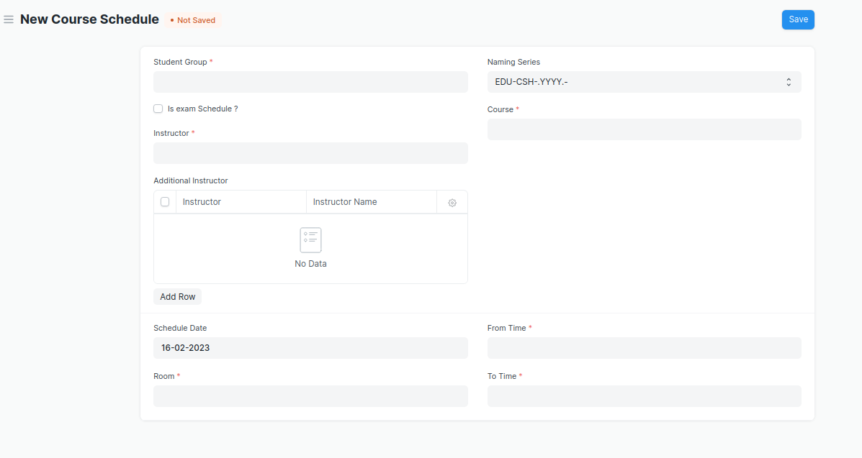

Figure 12 : Course Schedule Screen

**Field List**

The following table describes the UI fields present in this screen :

|  |  |  |  |  |  |  |
| --- | --- | --- | --- | --- | --- | --- |
| **ID** | **Field Name** | **Field Type** | **Validation/Action** | **Mandatory** | **Remarks** | **R/N/D** |
| 1 | Student Group | Link Field | Value will be fetched from student group list in a drop down. User will select . | Yes |  |  |
| 2 | Instructor | Link Field | Value will be fetched from the child table (Student Group Instructor) of the selected instructor | Yes |  | ( R ) Trainer |
| 3 | Instructor Name | Read only | Auto fetch instructor name from the above instruction field |  |  | ( R ) Trainer Name |
| 5 | Program | Link Field | Value will be fetched from the selected student group. |  |  | ( R ) Course |
| 6 | Course | Link Field | Value will be fetched from selected student group. | Yes |  | ( R ) Module |
| 7 | Schedule Date | Date | User will enter the schedule date of the course |  |  |  |
| 8 | Room | Link Field | Value will be fetched from the room list in a drop down . user will select. | Yes |  |  |
| 9 | From Time | Time | User will select the time. | Yes |  |  |
| 10 | To Time | Time | User will select the time. | Yes |  |  |

**Note: Course Scheduling Tool can be used for bulk scheduling of a course. **

**Users: Roles and Permissions**

The following table describes the users and their roles and permissions for the screens :

|  |  |  |  |  |  |  |  |  |
| --- | --- | --- | --- | --- | --- | --- | --- | --- |
| **ID** | **Role** | **Read** | **Write** | **Create** | **Delete** | **Submit** | **Cancel** | **Amend** |
| 1 | ToT coordinator/director | Yes | Yes | Yes | Yes | NA | NA | NA |
| 2 | ToT coordinator/administrator | Yes | Yes | Yes | Yes | NA | NA | NA |
| 3 | ToT assistant coordinator/trainer | Yes | No | No | No | NA | NA | NA |

### 3.4 Course Scheduling Tool

**General Description**

The following table describes overall information about this screen:

|  |  |
| --- | --- |
| **Description** | The Course Scheduling Tool allows a user to create Course Schedules in bulk for the particular Course. |
| **Navigation** | Home > Academics > Tools > Course Scheduling Tool |
| **Pre-requisites** | 1. Student Group  2. Instructor  3. Course  4. Class  5. Classroom |
| **Existing Screen Name** | Course Scheduling Tool |
| **New Screen Name** | Module Scheduling Tool |

**Screenshot**

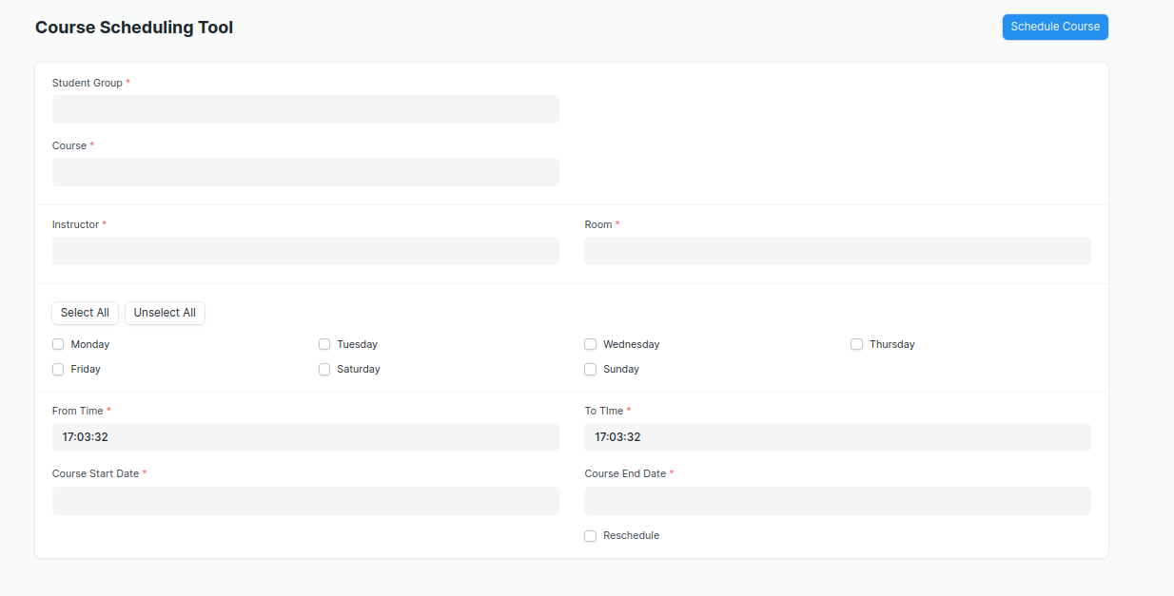

Figure 13 : Course Scheduling Tool Screen

**Field List**

The following table describes the UI fields present in this screen :

|  |  |  |  |  |  |  |
| --- | --- | --- | --- | --- | --- | --- |
| **ID** | **Field Name** | **Field Type** | **Validation/Action** | **Mandatory** | **Remarks** | **R/N/D** |
| 1 | Student Group | Link Field | Value will be fetched from Student Group List, User will select one of them | Yes |  |  |
| 2 | Course | Link Field | Value will be fetched from course list.User will select one. | Yes |  | ( R ) Module |
| 3 | Program | Link Field | Value will be fetched from  Program list, user will select. |  |  | ( R ) Course |
| 4 | Academic Year | Link Field | Value will be fetched from  Academic year list,user  Will select one. |  |  |  |
| 5 | Academic Term | Link Field | Based on the academic year,  Academic term will show in a drop down. User will select. |  |  |  |
| 6 | Instructor | Link Field | Value will be fetched from  Instructor list,user will select one. | Yes |  | ( R ) Trainer |
| 7 | Instructor Name | Read Only | Automatically filled up after  Selecting Instructor. |  |  | ( R ) Trainer Name |
| 8 | Room | Link Field | Value will be fetched from  Room list, user will select one. | Yes |  |  |
| 9 | From Time | Time | User will select time. | Yes |  |  |
| 10 | Course Start Date | Date | Start date should be before the End Date | Yes |  | ( R ) Module Start Date |
| 11 | To Time | Time | User will select time. | Yes |  |  |
| 12 | Course End Date | Date | Course End date should be greater then Course Start Date | Yes |  | ( R ) Module End Date |

1. User will Click on ‘Schedule Course’ Button.

**\*\*Note: The system should create the course schedules if the classroom and Instructor are**

**available and there is no conflict for the selected Student Group with other course**

**schedules.**

**Rescheduling**

1. User can reschedule the course schedules created.

2. User will Check the ‘Reschedule Checkbox and then click on ‘Schedule Course’.

3. System should delete the existing Course Schedules for the particular Course within the

mentioned Start Date and End Date and should create a new Course Schedules.

**\*\*The entries for all the Course Scheduling Tools should created in the Course Schedule**

**Document. \*\***

**Users: Roles and Permissions**

The following table describes the users and their roles and permissions for the screens :

|  |  |  |  |  |  |  |  |  |
| --- | --- | --- | --- | --- | --- | --- | --- | --- |
| **ID** | **Role** | **Read** | **Write** | **Create** | **Delete** | **Submit** | **Cancel** | **Amend** |
| 1 | ToT coordinator/director | Yes | Yes | Yes | Yes | NA | NA | NA |
| 2 | ToT coordinator/administrator | Yes | Yes | Yes | Yes | NA | NA | NA |
| 3 | ToT assistant coordinator/trainer | Yes | No | No | No | NA | NA | NA |

## **3.5 Student Attendance**

**General Description**

The following table describes overall information about this screen:

|  |  |
| --- | --- |
| **Description** | The Student Attendance allows you to keep track and mark the attendance of a student for a day. Attendance records can be created against students on a daily basis. |
| **Navigation** | Home > Academics > Attendance and Leave Application > Student Attendance |
| **Pre-requisites** | 1. Student  2. Course Schedule  3. Student Group |

**Screenshot**

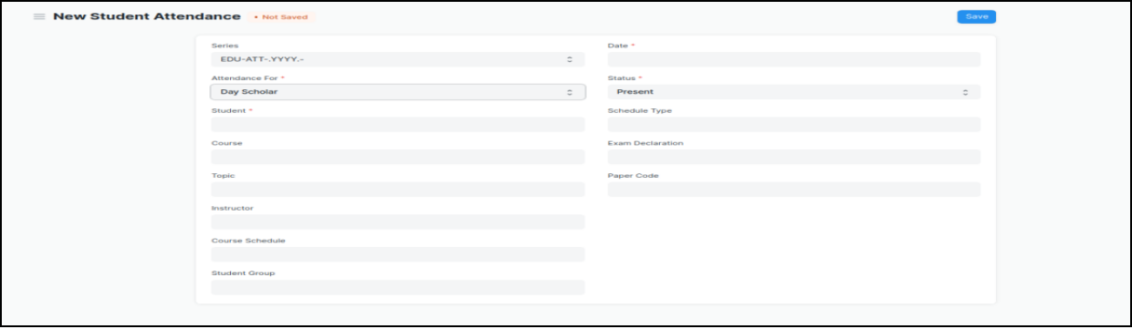

Figure 14 : Student Attendance Screen

**Field List:**

The following table describes the UI fields present in this screen :

|  |  |  |  |  |  |  |
| --- | --- | --- | --- | --- | --- | --- |
| **ID** | **Field Name** | **Field Type** | **Validation/Action** | **Mandatory** | **Remarks** | **R/N/D** |
| 1 | Student | Link Field | Value will be fetched from Student list,user will select . | Yes |  |  |
| 2 | Student Name | Read only | After selecting student id, this field will be  Automatically filled up. |  |  |  |
| 3 | Course Schedule | Link Field | Value will be fetched from course schedule list. |  |  | 1. Module Schedule |
| 4 | Student Group | Link Field | Value will be fetched from Student group list in which the student is present. |  |  |  |
| 5 | Date | Date | User will select the current date | Yes |  |  |
| 6 | Status | Dropdown | Options : Present, Absent,  User will select . | Yes |  |  |
| 7 | Course | Link Field | Value will be fetched from Course list that the student have enrolled.User will select |  |  | ( R ) Module |

**\*\*Note: The Attendance can be marked for the Exams and also the Student Attendance Tool can be used for bulk upgradation of the attendance.**

**Users: Roles and Permissions**

The following table describes the users and their roles and permissions for the screens :

|  |  |  |  |  |  |  |  |  |
| --- | --- | --- | --- | --- | --- | --- | --- | --- |
| **ID** | **Role** | **Read** | **Write** | **Create** | **Delete** | **Submit** | **Cancel** | **Amend** |
| 1 | ToT coordinator/director | Yes | Yes | Yes | Yes | Yes | Yes | Yes |
| 2 | ToT coordinator/administrator | Yes | Yes | Yes | Yes | Yes | Yes | Yes |
| 3 | ToT assistant coordinator/trainer | Yes | Yes | Yes | Yes | Yes | Yes | Yes |

## **3.6 Student Attendance Tool**

**General Description**

The following table describe overall information about this screen:

|  |  |
| --- | --- |
| **Description** | The Student Attendance Tool allows user to bulk update the Attendance for Students based on Student Group and Course Schedule. |
| **Navigation** | Home > Academics > Tools > Student Attendance Tool |
| **Pre-requisites** | 1. Student  2. Course Schedule  3. Student Group |

**Screenshot**

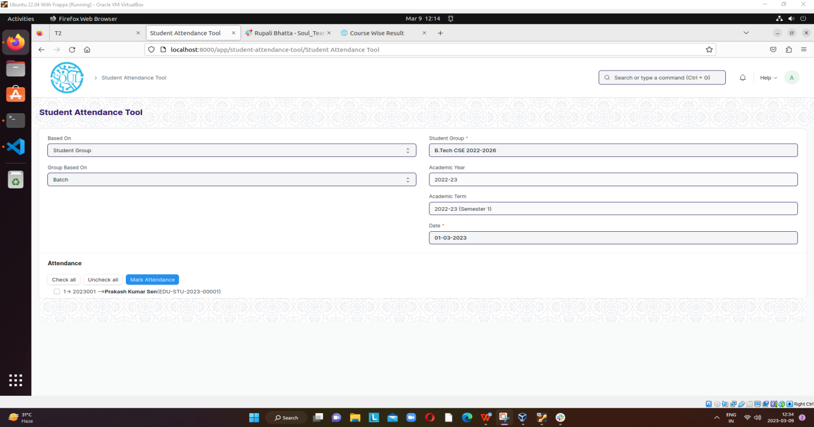

Figure 15 : Student Attendance Screen

**Field List**

The following table describes the UI fields present in this screen :

|  |  |  |  |  |  |  |
| --- | --- | --- | --- | --- | --- | --- |
| **ID** | **Field Name** | **Field Type** | **Validation/Action** | **Mandatory** | **Remarks** | **R/N/D** |
| 1 | Based On | Dropdown | Options : Student Group Course Schedule |  |  |  |
| 2 | Group Based On | Dropdown | Options :Batch Course Activity |  |  |  |
| 3 | Student Group | Link Field | Value will be fetched from  Student group list.User  Will select one. | Yes |  |  |
| 4 | Academic Year | Link Field | Value will be fetched from  Academic year,user will  Select one. |  |  |  |
| 5 | Academic Term | Link Field | Value will be fetched  Based on selected academic year. |  |  |  |
| 6 | Course Schedule | Link Field | Value will be fetched based on course schedule list. |  |  | ( R ) Module Schedule |
| 7 | Date | Date | User will select the date, Date should not be the future date | Yes |  |  |

**\*\*Note: In Student Attendance Screen Students attendance must be provided by an instructor before a specific deadline.\*\***

**Users: Roles and Permissions**

The following table describes the users and their roles and permissions for the screens :

|  |  |  |  |  |  |  |  |  |
| --- | --- | --- | --- | --- | --- | --- | --- | --- |
| **ID** | **Role** | **Read** | **Write** | **Create** | **Delete** | **Submit** | **Cancel** | **Amend** |
| 1 | ToT coordinator/director | Yes | Yes | Yes | Yes | NA | NA | NA |
| 2 | ToT coordinator/administrator | Yes | Yes | Yes | Yes | NA | NA | NA |
| 3 | ToT assistant coordinator/trainer | Yes | Yes | Yes | Yes | NA | NA | NA |

## 

## **3.7 Assignment**

**General Description**

The following table describes overall information about this screen:

|  |  |
| --- | --- |
| **Description** | In Assignment Screen Trainers can easily provide assignment to their respective students, so that it gives a strong bonding between the students and the trainers. |
| **Navigation** |  |
| **Pre-requisites** | 1. Instructor 2. Student Group |

**Screenshot**

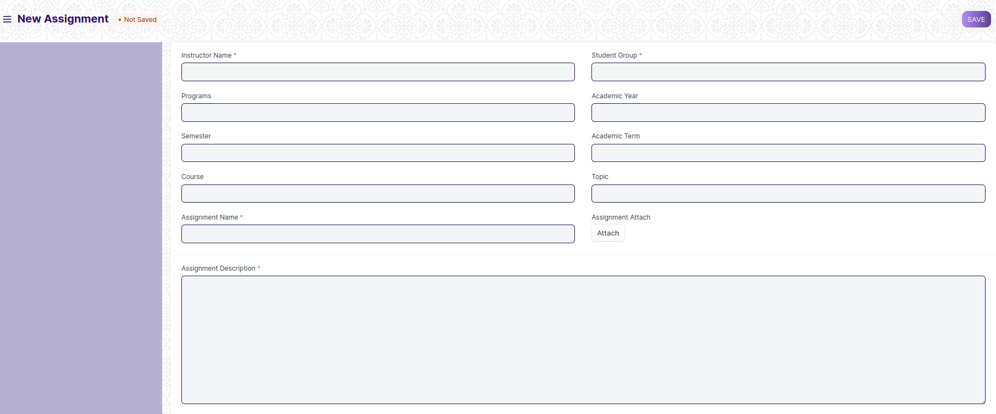

Figure 16 : Assignment Screen

**Field List**

The following table describes the UI fields present in this screen :

|  |  |  |  |  |  |  |
| --- | --- | --- | --- | --- | --- | --- |
| **ID** | **Field Name** | **Field Type** | **Validation/Action** | **Mandatory** | **Remarks** | **R/N/D** |
| 1 | Instructor Name | Link Field | Links with Instructor Screen, filters w.r.t Student Group | Yes |  |  |
| 2 | Student Group | Link Field | Links with Student Group Screen | Yes |  |  |
| 3 | Programs | Link Field | It will auto fetch when Student Group is entered, filters w.r.t Student Group |  |  | ( R ) Course |
| 4 | Semester | Link Field | It will auto fetch when Student Group is entered, filters w.r.t Student Group |  |  |  |
| 5 | Course | Link Field | It will auto fetch when Student Group is entered, filters w.r.t Student Group |  |  | ( R ) Module |
| 6 | Topic | Link Field | Links with Topic Screen and filters topics should come with respect to the above course field |  |  | (R) Sub Module |
| 7 | Assignment Name | Text | User Input | Yes |  |  |
| 8 | Assignment Attach Button | Attach | 1. On attachment a dialogue box will be popup where user can attach the files, images , takes the picture with the help camera and can link any URL.   If photos or images attached then the size will be maximum 200 kb. |  |  |  |
| 9 | Description | Long Text |  | Yes |  |  |
|  | Submit |  | On Submit the assignment will be able to visible only to their respective students. |  |  |  |

**Users: Roles and Permissions**

The following table describes the users and their roles and permissions for the screens :

|  |  |  |  |  |  |  |  |  |
| --- | --- | --- | --- | --- | --- | --- | --- | --- |
| **ID** | **Role** | **Read** | **Write** | **Create** | **Delete** | **Submit** | **Cancel** | **Amend** |
| 1 | ToT coordinator/director | Yes | Yes | Yes | Yes | NA | NA | NA |
| 2 | ToT coordinator/administrator | Yes | Yes | Yes | No | NA | NA | NA |
| 3 | ToT assistant coordinator/trainer | Yes | No | No | No | NA | NA | NA |

## 

## **3.8 Assignment Upload**

**General Description**

The following table describes overall information about this screen:

|  |  |
| --- | --- |
| **Description** | In Assignment Upload Screen Students can easily upload their assignment and it will securely go to their respective trainers. |
| **Navigation** |  |
| **Pre-requisites** | 1. Student Group 2. Assignment |

**Screenshot**

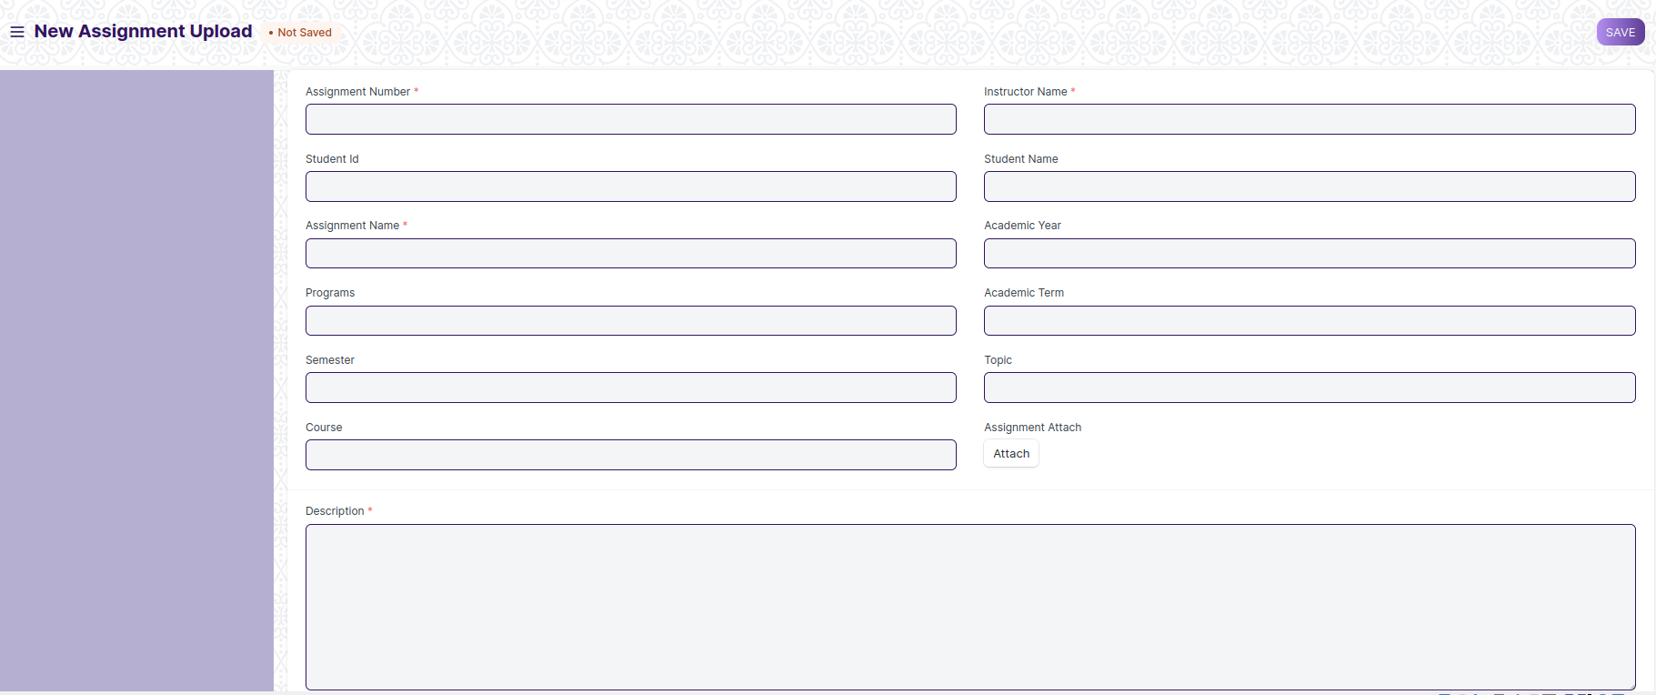

Figure 17: Assignment Upload

**Field Type**

The following table describes the UI fields present in this screen :

|  |  |  |  |  |  |  |
| --- | --- | --- | --- | --- | --- | --- |
| **ID** | **Field Name** | **Field Type** | **Validation/Action** | **Mandatory** | **Remarks** | **R/N/D** |
| 1 | Instructor Name | Link Field | Links with Instructor Screen | Yes |  |  |
| 2 | Assginment Number | Link Field | Links with Assignment Screen | Yes |  |  |
| 3 | Student Id | Link Field | Link with Student Screen |  |  |  |
| 4 | Student name | Text Field | It will auto fetch when Student Id is entered |  |  |  |
| 5 | Programs | Link Field | It will auto fetch when Student Id is entered |  |  | ( R ) Course |
| 6 | Semester | Link Field | It will auto fetch when Student Id is entered |  |  |  |
| 7 | Academic Year | Link Field | Link with Academic Year Screen |  |  |  |
| 8 | Academic Term | Link Field | Link with Academic Term and Value will be fetched based on selected Academic year. |  |  |  |
| 9 | Course | Link Field | It will auto fetch when Student Id is entered |  |  | ( R ) Module |
| 10 | Topic | Link Field | Links with Topic Screen and filters topics should come with respect to the course |  |  | (R) Sub Module |
| 11 | Assignment Name | Text | User Entered | Yes |  |  |
| 12 | Assignment Attach Button | Attach | 1. On attachment a dialogue box will be popup where user can attach the image, take the picture with the help camera and can link any URL. 2. If photos or images attached then the size will be maximum 200 kb. |  |  |  |
| 13 | Description | Long Text |  | Yes |  |  |
|  | Submit |  | On Submit assignment will be shown only to that particular instructor. |  |  |  |

**Users: Roles and Permissions**

The following table describes the users and their roles and permissions for the screens :

|  |  |  |  |  |  |  |  |  |
| --- | --- | --- | --- | --- | --- | --- | --- | --- |
| **ID** | **Role** | **Read** | **Write** | **Create** | **Delete** | **Submit** | **Cancel** | **Amend** |
| 1 | ToT coordinator/director | Yes | Yes | Yes | Yes | NA | NA | NA |
| 2 | ToT coordinator/administrator | Yes | Yes | Yes | No | NA | NA | NA |
| 3 | ToT assistant coordinator/trainer | Yes | No | No | No | NA | NA | NA |

## Examination

## **4.1 Exam Declaration**

**General Description**

|  |  |
| --- | --- |
| **Description** | The Exam Declaration will allow user to declare an exam for various programs in accordance with the ‘Academic Calendar’ template which was used during the start of each session. |
| **Navigation** | Home > Examination > Examination>Exam Declaration |
| **Pre-requisites** | 1. Academic Calendar 2. Program 3. Academic Year |
| **Existing Screen Name** | Exam Declaration |
| **New Screen Name** | NA |

### **Screenshot**

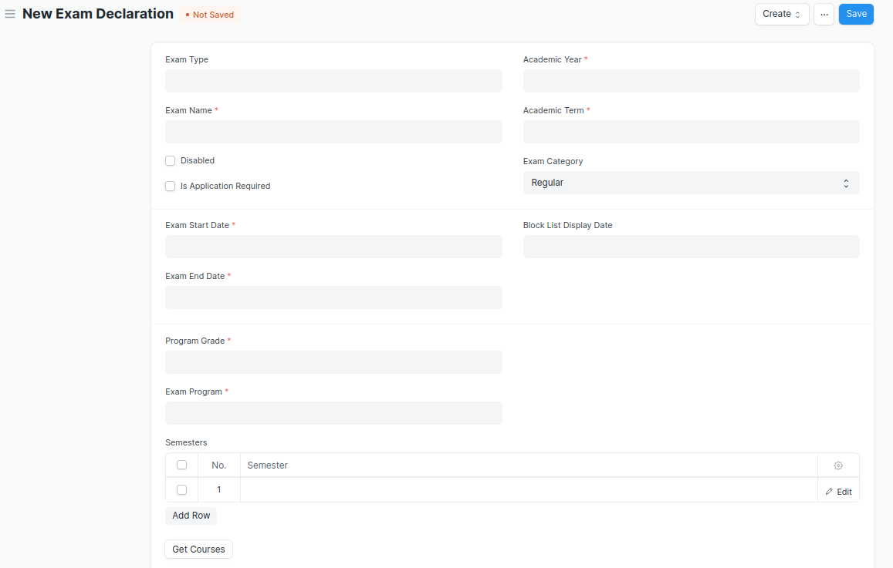

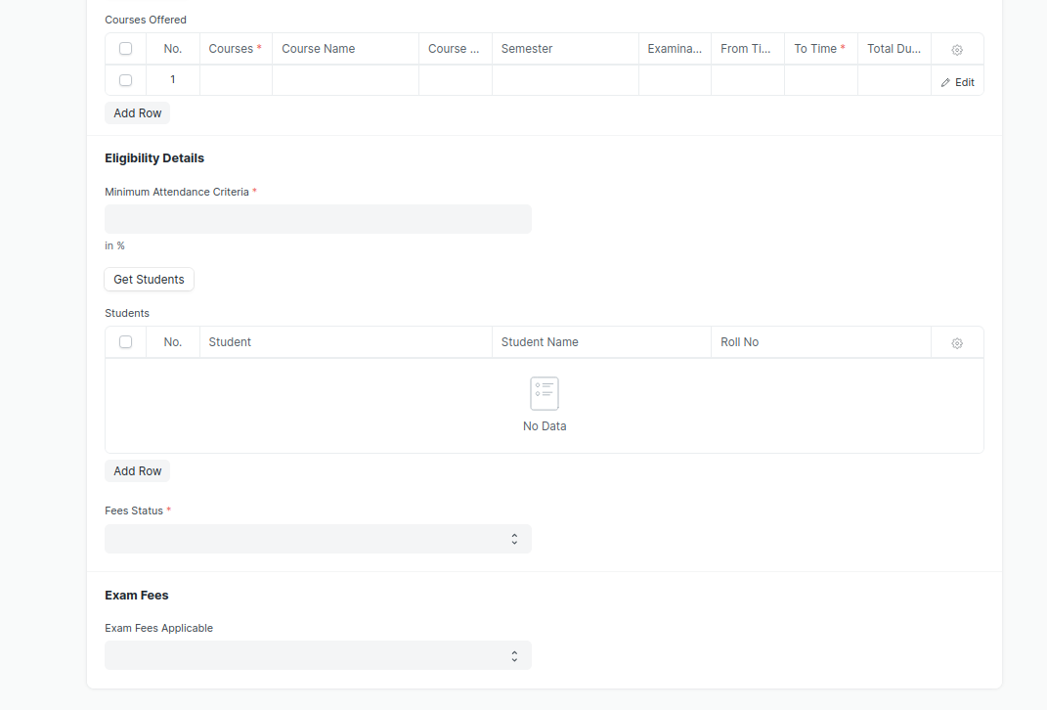

Figure 18 : Exam Declaration

### **Field List**

The “Exam Declaration” screen shall consist of the following fields:

|  |  |  |  |  |  |  |
| --- | --- | --- | --- | --- | --- | --- |
| **ID** | **Field Label** | **Field Type** | **Validation/Action** | **Mandatory** | **Remarks** | **R/N/D** |
| 1 | Exam Type | Link Field | Fetched from Exam Type master screen |  |  |  |
| 2 | Exam Name | Text Field | User Input | Y |  |  |
| 3 | Disabled | Checkbox | User Input |  |  |  |
| 4 | Is Application Required | Checkbox | User Input |  |  |  |
| 5 | Academic Year | Link Field | Fetched from Academic Year master screen | Y |  |  |
| 6 | Academic Term | Link Field | Fetched from Academic Term master screen | Y |  |  |
| 7 | Exam Category | Drop down | Regular/Re-Exam |  |  |  |
| 8 | Application Form Start Date | Date Picker | Display and Mandatory if “Is Application Required” is checked |  |  |  |
| 9 | Application Form End Date | Date Picker | 1. Display and Mandatory if “Is Application Required” is checked 2. Should be greater than Start Date |  |  |  |
| 10 | Exam Start Date | Date Picker | User Input | Y |  |  |
| 11 | Exam End Date | Date Picker | Should be greater than Start Date | Y |  |  |
| 12 | Admit Card Issue Date | Date Picker | User Input |  |  |  |
| 13 | Block List Display Date | Date Picker | Date should be before “Exam Start Date” |  |  |  |
| 14 | Program Grade | Link | Fetched from Program Grades master screen | Y |  | 1. Course Grade |
| 15 | Exam Program | Link | Program will be fetched based from selected “Program Grade” | Y |  | (R) Exam Course |
| 16 | **Semesters** | Table | Child table: Examination Semester | Y | These table is describe below |  |
| 17 | Get Courses | Button | Courses will be fetched based on Selected “Exam Program” and “Semester” |  |  | (R) Get Modules |
| 18 | **Courses Offered** | Table | Child table: Exam Courses | Y | These table is describe below | (R) Modules Offered |
| 19 | Minimum Attendance Criteria | Float | User Input | Y |  |  |
| 20 | Get Students | Button | Students will be fetched based on selected “Exam Program”,”Semester”,”Academic Year”,”Academic Term” |  |  |  |
| 21 | Total Enrolled Student | Number | Calculated total number of Students fetched based on “Get Students” Button |  |  |  |
| 22 | **Students** | Table | Child table: Students |  | These table is describe below |  |
| 23 | Fees Status | Drop down | Full Paid/  More than 50%/  Allow all | Y |  |  |
| 24 | Exam Fees Applicable | Drop down | YES/NO |  |  |  |
| 25 | **Fee Structure** | Table | If “Exam Fees Applicable” is “Yes” then table will show |  | These table is describe below |  |

|  |  |  |  |  |  |  |
| --- | --- | --- | --- | --- | --- | --- |
| **Semesters** | | | | | | |
| ID | **Field Label** | **Field Type** | **Validation/Action** | **Mandatory** | **Remarks** | **R/N/D** |
| 1 | Semester | Link Field | Fetched from Semester master screen and filtered based on Selected “Exam Program” | Y |  |  |

|  |  |  |  |  |  |  |
| --- | --- | --- | --- | --- | --- | --- |
|  | **Courses Offered** | | | | | |
| ID | **Field Label** | **Field Type** | **Validation/Action** | **Mandatory** | **Remarks** | **R/N/D** |
| 1 | Courses | Link Field | Auto fetch based on “Get Courses” Button | Y |  | (R) Modules |
| 2 | Course Name | Text field | Auto fetch based on “Get Courses” Button |  |  | (R) Modules Name |
| 3 | Course Code | Text field | Auto fetch based on “Get Courses” Button |  |  | (R) Modules Code |
| 4 | Semester | Link Field | Auto fetch based on “Get Courses” Button |  |  |  |
| 5 | Examination Date | Date Picker | User Input | Y |  |  |
| 6 | From Time | Time | User Input | Y |  |  |
| 7 | To Time | Time | User Input | Y |  |  |
| 8 | Total Duration (in Hours) | Time | Calculated based on “From Time” & “To Time” |  |  |  |

|  |  |  |  |  |  |  |
| --- | --- | --- | --- | --- | --- | --- |
| **Students** | | | | | | |
| **ID** | **Field Label** | **Field Type** | **Validation/Action** | **Mandatory** | **Remarks** | **R/N/D** |
| 1 | Student | Text Field | Auto fetch based on “Get student” Button |  |  |  |
| 2 | Student Name | Text Field | Auto fetch based on “Get student” Button |  |  |  |
| 3 | Roll No | Text Field | Auto fetch based on “Get student” Button |  |  |  |
| 4 | Registration Number | Text Field | Auto fetch based on “Get student” Button |  |  |  |

|  |  |  |  |  |  |  |
| --- | --- | --- | --- | --- | --- | --- |
| **Fee Structure** | | | | | | |
| **ID** | **Field Label** | **Field Type** | **Validation/Action** | **Mandatory** | **Remarks** | **R/N/D** |
| 1 | Student Category | Link Field | Fetched from Student Category master screen | Y |  |  |
| 2 | Fee Structure | Link Field | Fetched from Fee Structure master screen |  |  |  |
| 3 | Amount | Currency Field | Auto fetch based on “Fee Structure” |  |  |  |
| 4 | Due Date | Date Picker |  | Y |  |  |

**Note: A notification or mail will be sent directly to the student after the exam declaration are announced.**

**A field is required for exam Declaration to show which room and seat number will be used.**

**There should be a provision in the exam declaration form for assigning an invigilator, a marker, and a checker for each module.**

**User: Roles & Permission**

The following table describes the users and their roles and permissions for the screens :

|  |  |  |  |  |  |  |  |  |
| --- | --- | --- | --- | --- | --- | --- | --- | --- |
| **ID** | **Role** | **Read** | **Write** | **Create** | **Delete** | **Submit** | **Cancel** | **Amend** |
| 1 | ToT coordinator/director | Yes | Yes | Yes | Yes | Yes | Yes | Yes |
| 2 | ToT coordinator/administrator | Yes | Yes | Yes | Yes | Yes | Yes | Yes |
| 3 | ToT assistant coordinator/trainer | Yes | Yes | Yes | Yes | Yes | Yes | Yes |
|  | ToT candidate | Yes | No | No | No | No | No | No |

### Exam Attendance Sheet Print Format

**General Description**

|  |  |
| --- | --- |
| **Description** | On Click of Print button in Exam Declaration Screen a print format will be generated, it can also be converted into PDF format. |
| **Navigation** |  |
| **Pre-requisites** | Exam Declaration |
| **Existing Screen Name** |  |
| **New Screen Name** |  |

### **Exam Attendance Sheet Print Format Screenshot**

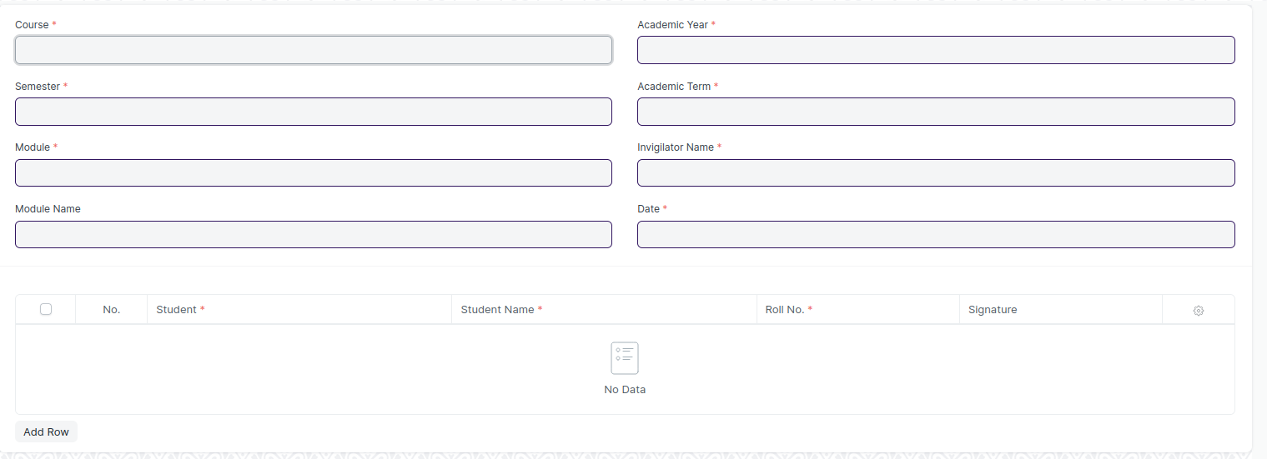

Figure 19 : Exam Attendance Sheet Print Format

### **Exam Attendance Sheet Print Format Field List**

The “Exam Attendance Sheet Print Format” screen shall consist of the following fields:

|  |  |  |  |  |  |  |
| --- | --- | --- | --- | --- | --- | --- |
| **ID** | **Field Label** | **Field Type** | **Validation/Action** | **Mandatory** | **Remarks** | **R/N/D** |
| 1 | Course | Link Field | Auto fetch based on “Exam Declaration” | Y |  | N |
| 2 | Semester | Text Field | Auto fetch based on “Exam Declaration” |  |  | N |
| 3 | Module | Link Field | Auto fetch based on “Exam Declaration” | Y |  | N |
| 4 | Module Name | Text Field | Auto fetch based on “Exam Declaration” |  |  | N |
| 5 | Academic Year | Link Field | Auto fetch based on “Exam Declaration” |  |  | N |
| 6 | Academic Term | Link Field | Auto fetch based on “Exam Declaration” |  |  | N |
| 7 | Trainer Name | Text Field | Auto fetch based on “Exam Declaration” | Y |  | N |
| 8 | **Students** | Table | Auto fetch based on “Exam Declaration” |  |  | N |

|  |  |  |  |  |  |  |
| --- | --- | --- | --- | --- | --- | --- |
| **Students** | | | | | | |
| **ID** | **Field Label** | **Field Type** | **Validation/Action** | **Mandatory** | **Remarks** | **R/N/D** |
| 1 | Student | Text Field | Auto fetch based on “Exam Declaration” |  |  |  |
| 2 | Student Name | Text Field | Auto fetch based on “Exam Declaration” |  |  |  |
| 3 | Roll No | Text Field | Auto fetch based on “Exam Declaration” |  |  |  |
| 4 | Registration Number | Text Field | Auto fetch based on “Exam Declaration” |  |  |  |

**User: Roles & Permission**

The following table describes the users and their roles and permissions for the screens :

|  |  |  |  |  |  |  |  |  |
| --- | --- | --- | --- | --- | --- | --- | --- | --- |
| **ID** | **Role** | **Read** | **Write** | **Create** | **Delete** | **Submit** | **Cancel** | **Amend** |
| 1 | ToT coordinator/director | Yes | Yes | Yes | Yes | Yes | Yes | Yes |
| 2 | ToT coordinator/administrator | Yes | Yes | Yes | Yes | Yes | Yes | Yes |
| 3 | ToT assistant coordinator/trainer | Yes | Yes | Yes | Yes | Yes | Yes | Yes |
|  | ToT candidate | Yes | No | No | No | No | No | No |

### Exam Score Sheet Print Format

**General Description**

|  |  |
| --- | --- |
| **Description** | On Click of Print button in Exam Declaration Screen a print format will be generated, it can also be converted into PDF format. |
| **Navigation** |  |
| **Pre-requisites** | Exam Declaration |
| **Existing Screen Name** |  |
| **New Screen Name** |  |

### **Exam Score Sheet Print Format Screenshot**

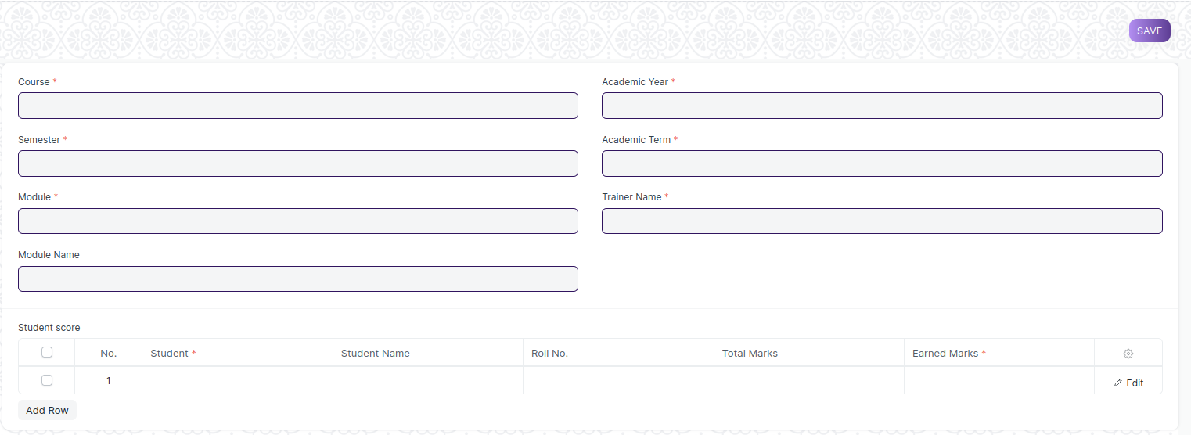

Figure 20 : Exam Score Sheet Print Format

### **Exam Score Sheet Print Format Field List**

The “Exam Score Sheet Print Format” screen shall consist of the following fields:

|  |  |  |  |  |  |  |
| --- | --- | --- | --- | --- | --- | --- |
| **ID** | **Field Label** | **Field Type** | **Validation/Action** | **Mandatory** | **Remarks** | **R/N/D** |
| 1 | Course | Link Field | Auto fetch based on “Exam Declaration” | Y |  | N |
| 2 | Semester | Link Field | Auto fetch based on “Exam Declaration” | Y |  | N |
| 3 | Module | Link Field | Auto fetch based on “Exam Declaration” | Y |  | N |
| 4 | Module Name | Text Field | Auto fetch based on “Exam Declaration” |  |  | N |
| 5 | Academic Year | Link Field | Auto fetch based on “Exam Declaration” |  |  | N |
| 6 | Academic Term | Link Field | Auto fetch based on “Exam Declaration” |  |  | N |
| 7 | Invigilator Name | Text Field | Auto fetch based on “Exam Declaration” | Y |  | N |
| 8 | Date | Date Picker | Auto fetch based on “Exam Declaration” |  |  | N |
| 9 | **Students** | Table | Auto fetch based on “Exam Declaration” |  |  | N |

|  |  |  |  |  |  |  |
| --- | --- | --- | --- | --- | --- | --- |
| **Students** | | | | | | |
| **ID** | **Field Label** | **Field Type** | **Validation/Action** | **Mandatory** | **Remarks** | **R/N/D** |
| 1 | Student | Text Field | Auto fetch based on “Exam Declaration” |  |  |  |
| 2 | Student Name | Text Field | Auto fetch based on “Exam Declaration” |  |  |  |
| 3 | Roll No | Text Field | Auto fetch based on “Exam Declaration” |  |  |  |
| 4 | Registration Number | Text Field | Auto fetch based on “Exam Declaration” |  |  |  |
| 5 | Earned Marks | Number | User Input |  |  |  |
| 6 | Total Marks | Number | User Input |  |  |  |

### **User: Roles & Permission**

The following table describes the users and their roles and permissions for the screens :

|  |  |  |  |  |  |  |  |  |
| --- | --- | --- | --- | --- | --- | --- | --- | --- |
| **ID** | **Role** | **Read** | **Write** | **Create** | **Delete** | **Submit** | **Cancel** | **Amend** |
| 1 | ToT coordinator/director | Yes | Yes | Yes | Yes | Yes | Yes | Yes |
| 2 | ToT coordinator/administrator | Yes | Yes | Yes | Yes | Yes | Yes | Yes |
| 3 | ToT assistant coordinator/trainer | Yes | Yes | Yes | Yes | Yes | Yes | Yes |
|  | ToT candidate | Yes | No | No | No | No | No | No |

## 

## **4.2 Criteria Wise Evaluation**

**General Description**

|  |  |
| --- | --- |
| **Description** | Criteria Wise Evaluation allows us to create an evaluation for a particular assessment criterion in a course for a student enrolled in that course. |
| **Navigation** | Home > Examination > Evaluation > Criteria Wise Evaluation |
| **Pre-requisites** | 1. Exam Declaration 2. Course 3. Assessment Criteria 4. Grading Scale |
| **Existing Screen Name** | Criteria Wise Evaluation |
| **New Screen Name** | NA |

### **Screenshot**

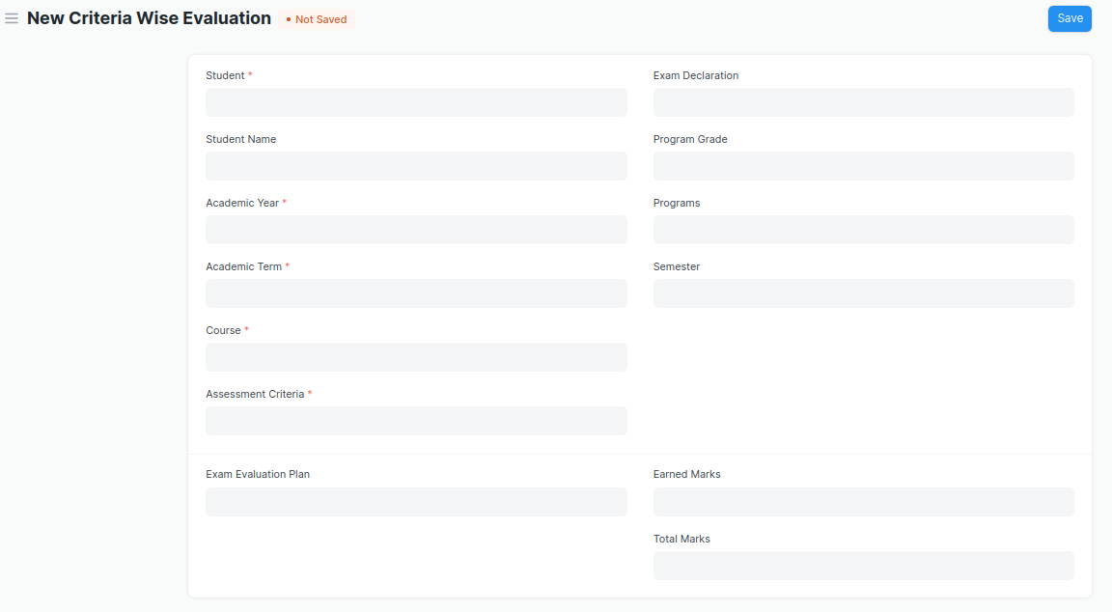

Figure 23 : Criteria Wise Evaluation Screen

* Two instructors independently evaluate a student's assessment without knowing the other's score and then come together to compare their results and determine the final grade.

### **Field List**

The “Criteria Wise Evaluation” screen shall consist of the following fields:

|  |  |  |  |  |  |  |
| --- | --- | --- | --- | --- | --- | --- |
| **ID** | **Field Label** | **Field Type** | **Validation/Action** | **Mandatory** | **Remarks** | **R/N/D** |
| 1 | Student | Link Field | Fetched from student master screen | Y |  |  |
| 2 | Student Name | Text Field | Auto fetch based on Student |  |  |  |
| 3 | Roll No | Text Field | Auto fetch based on Student |  |  |  |
| 4 | Registration Number | Text Field | Auto fetch based on Student |  |  |  |
| 5 | Academic Year | Link Field | Auto fetched based on selected “Exam Declaration” | Y |  |  |
| 6 | Academic Term | Link Field | Auto fetched based on selected “Exam Declaration” | Y |  |  |
| 7 | Course | Link Field | Fetched from Course master screen, filtered will be applied Student enrolled course | Y |  | (R) Module |
| 8 | Course Name | Text Field | Auto fetch based on Course |  |  | (R) Module Name |
| 9 | Assessment Criteria | Link Field | Fetched from Assessment Criteria master screen | Y |  |  |
| 10 | Exam Declaration | Link Field | Fetched from Exam Declaration master screen |  |  |  |
| 11 | Program Grade | Link Field | Fetched from Program Grades master screen |  |  | (R) Course Grade |
| 12 | Programs | Link Field | Auto fetched based on selected “Exam Declaration” |  |  | (R) Course |
| 13 | Semester | Link Field | Fetched from Semester master screen,filtered will applied selected Programs |  |  |  |
| 14 | Exam Assessment Plan | Link Field | Fetched from Exam Assessment Plan master screen |  |  |  |
| 15 | Earned Marks | Float |  |  |  |  |
| 16 | Total Marks | Float | Auto fetched based on selected Course from Course master |  |  |  |

### **User: Roles & Permission**

The following table describes the users and their roles and permissions for the screens :

|  |  |  |  |  |  |  |  |  |
| --- | --- | --- | --- | --- | --- | --- | --- | --- |
| **ID** | **Role** | **Read** | **Write** | **Create** | **Delete** | **Submit** | **Cancel** | **Amend** |
| 1 | ToT coordinator/director | Yes | Yes | Yes | Yes | NA | NA | NA |
| 2 | ToT coordinator/administrator | Yes | Yes | Yes | No | NA | NA | NA |
| 3 | ToT assistant coordinator/trainer | Yes | No | No | No | NA | NA | NA |

## **4.3 Criteria Wise Evaluation Tool**

**General Description**

|  |  |
| --- | --- |
| **Description** | Criteria Wise Evaluation Tool helps in entering marks earned by the students in a semester for a particular course and particular assessment criteria. |
| **Navigation** | Home > Examination > Tools > Criteria Wise Evaluation Tool |
| **Pre-requisites** | 1. Exam Declaration 2. Course 3. Assessment Criteria 4. Grading Scale |
| **Existing Screen Name** | Criteria Wise Evaluation Tool |
| **New Screen Name** | NA |

### **Screenshot**

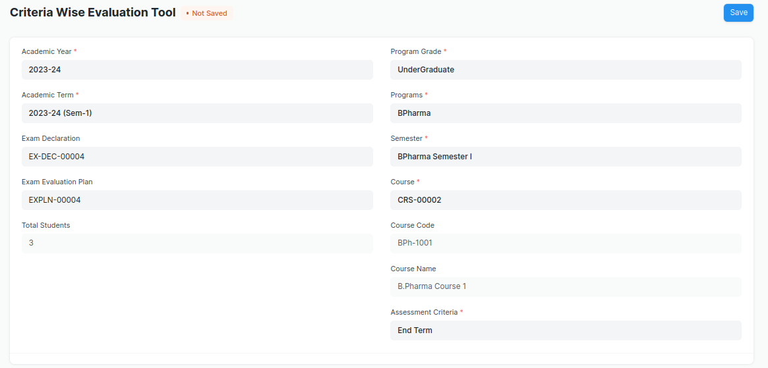

Figure 24 : Criteria Wise Evaluation Tool Screen

### **Field List**

The “Criteria Wise Evaluation Tool” screen shall consist of the following fields:

|  |  |  |  |  |  |  |
| --- | --- | --- | --- | --- | --- | --- |
| **ID** | **Field Label** | **Field Type** | **Validation/Action** | **Mandatory** | **Remarks** | **R/N/D** |
| 1 | Academic Year | Link Field | Fetched from Academic Year master screen | Y |  |  |
| 2 | Academic Term | Link Field | Fetched from Academic Term master screen and filter applied on the basis of Academic Year | Y |  |  |
| 3 | Exam Declaration | Link Field | Fetched from Exam Declaration master screen and filtered applied on the basis of Semester and Academic Term |  |  |  |
| 4 | Exam Assessment Plan | Link Field | Fetched from Exam Assessment Plan master screen |  |  |  |
| 5 | Total Students | Number |  |  |  |  |
| 6 | Program Grade | Link Field | Fetched from Program Grades master screen |  |  | (R)  Course Grade |
| 7 | Programs | Link Field | Fetched from Programs master screen, filtered applied on the basis of Program Grade |  |  | (R)  Courses |
| 8 | Semester | Link Field | Fetched from Program master screen and filtered applied on the basis of Programs |  |  |  |
| 9 | Course | Link Field | Fetched from Course master screen and filtered applied on the basis of Semester | Y |  | (R)  Module |
| 10 | Course Code | Text Field | Auto fetch based on Course |  |  | (R)  Module Code |
| 11 | Course Name | Text Field | Auto fetch based on Course |  |  | (R)  Module Name |
| 12 | Assessment Criteria | Link Field | Fetched from Assessment Criteria master screen | Y |  |  |
| 13 | **Student Details Data** | Table |  |  | These table is describe below |  |

|  |  |  |  |  |  |  |
| --- | --- | --- | --- | --- | --- | --- |
| **Student Details Data** | | | | | | |
| **ID** | **Field Label** | **Field Type** | **Validation/Action** | **Mandatory** | **Remarks** | **R/N/D** |
| 1 | Student | HTML Field | Auto fetched when all the above relevant inputs given |  |  |  |
| 2 | Student Name | HTML Field | Auto fetched when all the above relevant inputs given |  |  |  |
| 3 | Roll No | HTML Field | Auto fetched when all the above relevant inputs given |  |  |  |
| 4 | Earned Marks | HTML Field | Auto fetched when all the above relevant inputs given |  |  |  |
| 5 | Total Marks | HTML Field | Auto fetched when all the above relevant inputs given |  |  |  |

### **User: Roles & Permission**

The following table describes the users and their roles and permissions for the screens :

|  |  |  |  |  |  |  |  |  |
| --- | --- | --- | --- | --- | --- | --- | --- | --- |
| **ID** | **Role** | **Read** | **Write** | **Create** | **Delete** | **Submit** | **Cancel** | **Amend** |
| 1 | ToT coordinator/director | Yes | Yes | Yes | Yes | NA | NA | NA |
| 2 | ToT coordinator/administrator | Yes | Yes | Yes | No | NA | NA | NA |
| 3 | ToT assistant coordinator/trainer | Yes | No | No | No | NA | NA | NA |

## **4.4 Continuous Evaluation**

**General Description**

|  |  |
| --- | --- |
| **Description** | Continuous Evaluation is used to assess the Assessment Criteria done for a course for an individual student. |
| **Navigation** | Home > Examination > Evaluation > Continuous Evaluation |
| **Pre-requisites** | Criteria Wise Evaluation |
| **Existing Screen Name** | Continuous Evaluation |
| **New Screen Name** | NA |

### **Screenshot**

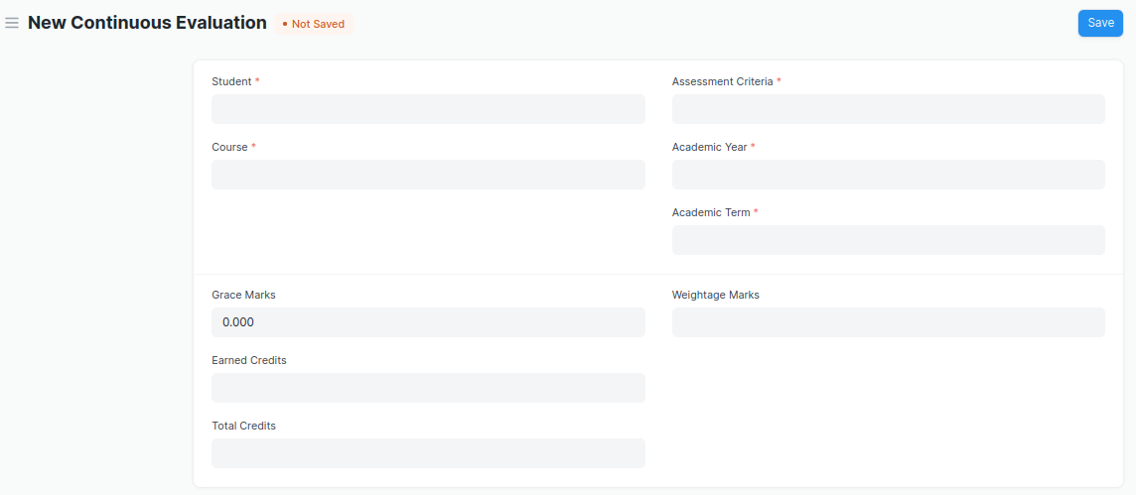

Figure 25 : Continuous Evaluation Screen

### **Field List**

The “Continuous Evaluation” screen shall consist of the following fields:

|  |  |  |  |  |  |  |
| --- | --- | --- | --- | --- | --- | --- |
| **ID** | **Field Label** | **Field Type** | **Validation/Action** | **Mandatory** | **Remarks** | **R/N/D** |
| 1 | Student | Link Field | Fetched from student master screen | Y |  |  |
| 2 | Student Name | Text Field | Auto fetch based on Student |  |  |  |
| 3 | Course | Link Field | Fetched from Course master screen | Y |  | (R) Module |
| 4 | Roll No | Text Field | Auto fetch based on Student |  |  |  |
| 5 | Registration Number | Text Field | Auto fetch based on Student |  |  |  |
| 6 | Course Code | Text Field | Auto fetch based on Course |  |  | (R) Module Code |
| 7 | Course Name | Text Field | Auto fetch based on Course |  |  | (R) Module Name |
| 8 | Assessment Criteria | Link Field | Fetched from Assessment Criteria master screen | Y |  |  |
| 9 | Academic Year | Link Field | Fetched from Academic Year master screen | Y |  |  |
| 10 | Academic Term | Link Field | Fetched from Academic Term master screen | Y |  |  |
| 11 | Get Assessments | Button | User Input |  |  |  |
| 12 | **Final Credit Item** | Table | Child Table: Final Credit Item | Y | These table is describe below |  |
| 13 | Grace Marks | Float | User Input If needed |  |  |  |
| 14 | Earned Credits | Float |  |  |  | ( D ) |
| 15 | Total Credits | Float |  |  |  | ( D ) |
| 16 | Weightage Marks | Float | Fetched from Course master screen |  |  |  |
| 17 | Final Marks | Float | Fetched from criteria wise evaluation screen respective record | Y |  |  |
| 18 | Out of Marks | Float | Fetched from Course master screen |  |  |  |

|  |  |  |  |  |  |  |
| --- | --- | --- | --- | --- | --- | --- |
| **Final Credit Item** | | | | | | |
| **ID** | **Field Label** | **Field Type** | **Validation/Action** | **Mandatory** | **Remarks** | **R/N/D** |
| 1 | Course Assessment | Link Field | Fetched from Course Assessment master screen |  |  |  |
| 2 | Earned Marks | Float | Auto Fetched from criteria wise evaluation screen respective record |  |  |  |
| 3 | Grace Marks | Float | User Input If needed |  |  |  |
| 4 | Total Marks | Float | Auto Fetched from criteria wise evaluation screen respective record |  |  |  |

### **User: Roles & Permission**

The following table describes the users and their roles and permissions for the screens :

|  |  |  |  |  |  |  |  |  |
| --- | --- | --- | --- | --- | --- | --- | --- | --- |
| **ID** | **Role** | **Read** | **Write** | **Create** | **Delete** | **Submit** | **Cancel** | **Amend** |
| 1 | ToT coordinator/director | Yes | Yes | Yes | Yes | NA | NA | NA |
| 2 | ToT coordinator/administrator | Yes | Yes | Yes | No | NA | NA | NA |
| 3 | ToT assistant coordinator/trainer | Yes | No | No | No | NA | NA | NA |

## **4.5 Continuous Evaluation Tool**

**General Description**

|  |  |
| --- | --- |
| **Description** | Continuous Evaluation Tool is used to assess the Assessment Criteria done for a course for an individual student. |
| **Navigation** | Home > Examination > Tools > Continuous Evaluation Tool |
| **Pre-requisites** | Criteria Wise Evaluation |
| **Existing Screen Name** | Continuous Evaluation Tool |
| **New Screen Name** | NA |

### **Screenshot**

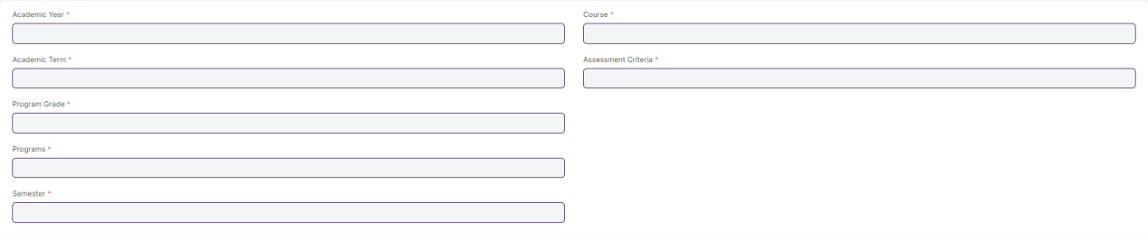

Figure 26 : Continuous Evaluation Screen

### **Field List**

The “Continuous Evaluation Tool” screen shall consist of the following fields:

|  |  |  |  |  |  |  |
| --- | --- | --- | --- | --- | --- | --- |
| **ID** | **Field Label** | **Field Type** | **Validation/Action** | **Mandatory** | **Remarks** | **R/N/D** |
| 1 | Academic Year | Link Field | Fetched from Academic Year master screen | Y |  |  |
| 2 | Academic Term | Link Field | Fetched from Academic Term master screen and filtered applied on the basis of Academic Year | Y |  |  |
| 3 | Program Grade | Link Field | Fetched from Program Grades master screen | Y |  | (R) Course Grade |
| 4 | Programs | Link Field | Fetched from Programs master screen and filtered applied on the basis of Program Grades |  |  | (R) Courses |
| 5 | Semester | Link Field | Fetched from Program master screen and filtered applied on the basis of Programs |  |  |  |
| 6 | Course | Link Field | Fetched from Course master screen and filtered applied on the basis of Semester | Y |  | (R) Module |
| 7 | Course Code | Text Field | Auto fetch based on Course |  |  | (R) Module Code |
| 8 | Course Name | Text Field | Auto fetch based on Course |  |  | (R) Module Name |
| 9 | Assessment Criteria | Link Field | Fetched from Assessment Criteria master screen | Y |  |  |
| 10 | Student Inputs | HTML |  |  |  |  |

|  |  |  |  |  |  |  |
| --- | --- | --- | --- | --- | --- | --- |
| **Student Details Data** | | | | | | |
| **ID** | **Field Label** | **Field Type** | **Validation/Action** | **Mandatory** | **Remarks** | **R/N/D** |
| 1 | Student | HTML Field | Auto fetched when all the above relevant inputs given |  |  |  |
| 2 | Student Name | HTML Field | Auto fetched when all the above relevant inputs given |  |  |  |
| 3 | Roll No | HTML Field | Auto fetched when all the above relevant inputs given |  |  |  |
| 4 | Earned Marks | HTML Field | Auto fetched when all the above relevant inputs given |  |  |  |
| 5 | Total Marks | HTML Field | Auto fetched when all the above relevant inputs given |  |  |  |

### **User: Roles & Permission**

The following table describes the users and their roles and permissions for the screens :

|  |  |  |  |  |  |  |  |  |
| --- | --- | --- | --- | --- | --- | --- | --- | --- |
| **ID** | **Role** | **Read** | **Write** | **Create** | **Delete** | **Submit** | **Cancel** | **Amend** |
| 1 | ToT coordinator/director | Yes | Yes | Yes | Yes | NA | NA | NA |
| 2 | ToT coordinator/administrator | Yes | Yes | Yes | Yes | NA | NA | NA |
| 3 | ToT assistant coordinator/trainer | Yes | No | No | No | NA | NA | NA |

## **4.6 Final Exam Result**

**General Description**

|  |  |
| --- | --- |
| **Description** | Final Exam Result is used to evaluate the final assessment of a student for a particular semester. |
| **Navigation** | Home > Examination > Evaluation > Final Exam Result |
| **Pre-requisites** | Continuous Evaluation |
| **Existing Screen Name** | Final Exam Result |
| **New Screen Name** | NA |

### **Screenshot**

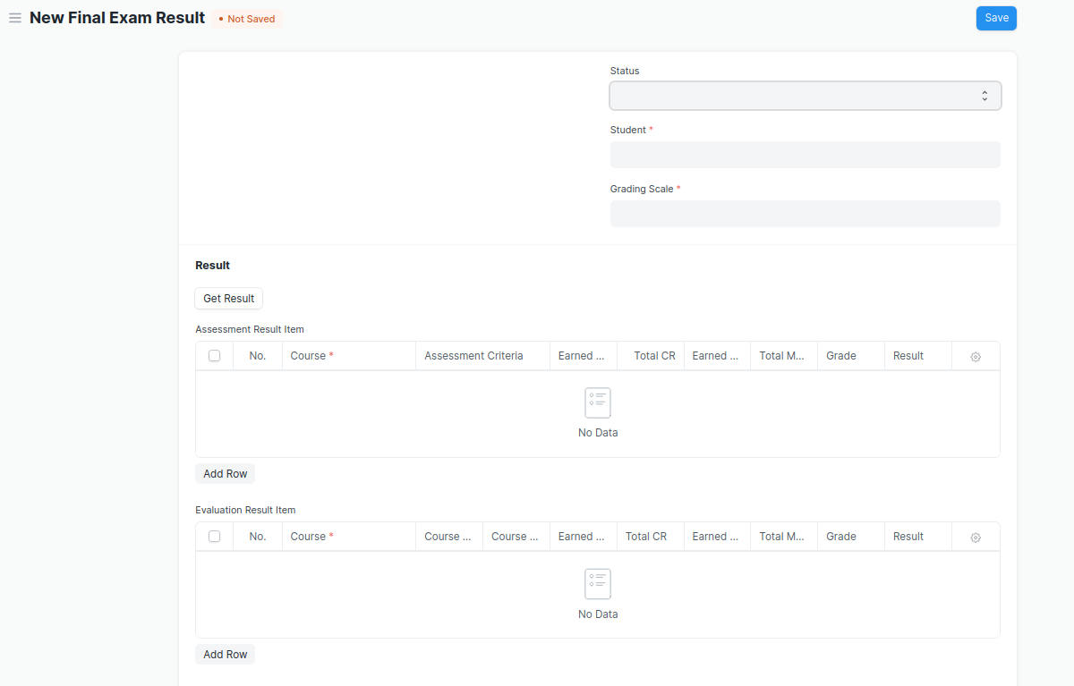

Figure 26 : Final Exam Result Screen

### **Field List**

The “Final Exam Result” screen shall consist of the following fields:

|  |  |  |  |  |  |  |
| --- | --- | --- | --- | --- | --- | --- |
| **ID** | **Field Label** | **Field Type** | **Validation/Action** | **Mandatory** | **Remarks** | **R/N/D** |
| 1 | Programs | Link Field | Auto fetch when Student Id is entered |  |  | (R) Courses |
| 2 | Semester | Link Field | Need to be entered manually. |  |  |  |
| 3 | Course | Link Field | Auto fetch when Student Id is entered |  |  | (R) Module |
| 4 | Academic Year | Link Field | Auto fetch when Student Id is entered |  |  |  |
| 5 | Academic Term | Link Field | Need to be entered manually |  |  |  |
| 6 | Student | Link Field | Fetched from student master screen |  |  |  |
| 7 | Student Name | Text Field | Auto fetch when Student Id is entered |  |  |  |
| 8 | Roll No | Text Field | Auto fetch when Student Id is entered |  |  |  |
| 9 | Registration Number | Text Field | Auto fetch when Student Id is entered |  |  |  |
| 10 | Grading Scale | Link Field | Fetched from Grading Scale master screen |  |  |  |
| 11 | Assessment Status | Text Field |  |  |  |  |
| 12 | Get Result | Button |  |  |  |  |
| 13 | **Assessment Result Item** | Table | After Clicking on Get Result, the **Assessment Result Item** table will auto fetch**.** |  | These table is describe below |  |
| 14 | **Evaluation Result Item** | Table | This table will visible when a record is in **Draft** Status |  | These table is describe below |  |
| 15 | Result | Text Field | Auto Calculated after saving the record |  |  |  |
| 16 | Grade | Text Field | Auto Calculated after saving the record |  |  | (N) |
| 17 | Overall Grade | Text Field | Auto Calculated after saving the record |  |  | (N) |
| 18 | Comment | Small Text Field |  |  |  |  |
| 19 | SGPA |  |  |  |  | ( D ) |
| 20 | Overall CGPA |  |  |  |  | ( D ) |

|  |  |  |  |  |  |  |
| --- | --- | --- | --- | --- | --- | --- |
| **Assessment Result Item** | | | | | | |
| **ID** | **Field Label** | **Field Type** | **Validation/Action** | **Mandatory** | **Remarks** | **R/N/D** |
| 1 | Course | Link Field | Fetched from Course master screen | Y |  | (R) Module |
| 2 | Assessment Criteria | Link Field | Fetched from Assessment Criteria master screen |  |  |  |
| 3 | Earned CR | Float | Auto fetched on the basis of Get Result Button |  |  | ( D ) |
| 4 | Total CR | Float | Auto fetched on the basis of Get Result Button |  |  | ( D ) |
| 5 | Earned Marks | Float | Auto fetched on the basis of Get Result Button |  |  |  |
| 6 | Total Marks | Float | Auto fetched on the basis of Get Result Button |  |  |  |
| 7 | Grade | Text Field | Auto fetched on the basis of Get Result Button |  |  |  |
| 8 | Result | Drop down | Auto fetched on the basis of Get Result Button | P/F |  |  |

|  |  |  |  |  |  |  |
| --- | --- | --- | --- | --- | --- | --- |
| **Evaluation Result Item (This table will visible when the record is in draft stage)** | | | | | | |
| **ID** | **Field Label** | **Field Type** | **Validation/Action** | **Mandatory** | **Remarks** | **R/N/D** |
| 1 | Course | Link Field | Fetched from Course master screen | Y |  | (R) Module |
| 2 | Course Code | Text Field | Auto fetch based on Course |  |  | (R) Module Code |
| 3 | Course Name | Text Field | Auto fetch based on Course |  |  | (R) Module Name |
| 4 | Earned CR | Float |  |  |  | ( D ) |
| 5 | Total CR | Text Field |  |  |  | ( D ) |
| 6 | Earned Marks | Text Field |  |  |  |  |
| 7 | Total Marks | Text Field |  |  |  |  |
| 8 | Grade | Text Field |  |  |  |  |
| 9 | Result | Drop down | P/F |  |  |  |

### **User: Roles & Permission**

The following table describes the users and their roles and permissions for the screens :

|  |  |  |  |  |  |  |  |  |
| --- | --- | --- | --- | --- | --- | --- | --- | --- |
| **ID** | **Role** | **Read** | **Write** | **Create** | **Delete** | **Submit** | **Cancel** | **Amend** |
| 1 | ToT coordinator/director | Yes | Yes | Yes | Yes | NA | NA | NA |
| 2 | ToT coordinator/administrator | Yes | Yes | Yes | No | NA | NA | NA |
| 3 | ToT assistant coordinator/trainer | Yes | No | No | No | NA | NA | NA |

## **4.7 Final Result Declaration Tool**

**General Description**

|  |  |
| --- | --- |
| **Description** | Final Result Declaration Tool is used to declare the final exam results for a particular group/batch of students in a semester. |
| **Navigation** | Home > Examination > Tools > Final Result Declaration Tool |
| **Pre-requisites** | Continuous Evaluation |
| **Existing Screen Name** | Final Result Declaration Tool |
| **New Screen Name** | NA |

### **Screenshot**

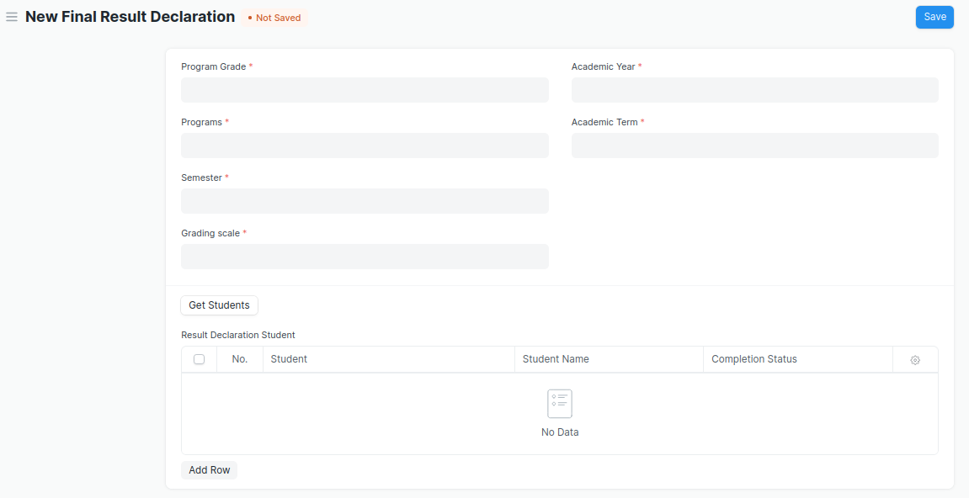

Figure 27 : Final Result Declaration Tool Screen

### **Field List**

The “Final Result Declaration Tool” screen shall consist of the following fields:

|  |  |  |  |  |  |  |
| --- | --- | --- | --- | --- | --- | --- |
| **ID** | **Field Label** | **Field Type** | **Validation/Action** | **Mandatory** | **Remarks** | **R/N/D** |
| 1 | Program Grade | Link Field | Fetched from Program Grades master screen | Y |  |  |
| 2 | Programs | Link Field | Fetched from Programs master screen and filtered applied on the basis of Program Grade | Y |  |  |
| 3 | Semester | Link Field | Fetched from Program master screen and filtered applied on the basis of Programs | Y |  |  |
| 4 | Grading scale | Link Field | Fetched from Grading Scale master screen | Y |  |  |
| 5 | Academic Year | Link Field | Fetched from Academic Year master screen | Y |  |  |
| 6 | Academic Term | Link Field | Fetched from Academic Term master screen and filtered applied on the basis of Academic Year | Y |  |  |
| 7 | Result Creation Status | Drop Down | In Process  Failed  Successful |  |  |  |
| 8 | Get Students | Button | User Input |  |  |  |
| 9 | Total Enrolled Student | Number | Auto created when clicked on Get Student Button |  |  |  |
| 10 | **Result Declaration Student** | Table | Child Table: Result Declaration Student |  | These table is describe below |  |

|  |  |  |  |  |  |  |
| --- | --- | --- | --- | --- | --- | --- |
| **Result Declaration Student** | | | | | | |
| **ID** | **Field Label** | **Field Type** | **Validation/Action** | **Mandatory** | **Remarks** | **R/N/D** |
| 1 | Student | Link Field | Fetched from Student master screen |  |  |  |
| 2 | Student Name | Text Field | Auto fetch based on Student |  |  |  |
| 3 | Roll No | Text Field | Auto fetch based on Student |  |  |  |

### **User: Roles & Permission**

The following table describes the users and their roles and permissions for the screens :

|  |  |  |  |  |  |  |  |  |
| --- | --- | --- | --- | --- | --- | --- | --- | --- |
| **ID** | **Role** | **Read** | **Write** | **Create** | **Delete** | **Submit** | **Cancel** | **Amend** |
| 1 | ToT coordinator/director | Yes | Yes | Yes | Yes | NA | NA | NA |
| 2 | ToT coordinator/administrator | Yes | Yes | Yes | No | NA | NA | NA |
| 3 | ToT assistant coordinator/trainer | Yes | No | No | No | NA | NA | NA |